**The Anthropocene: Mitigation, Adaptation, Suffering**

**INDS 430**

**Tuesdays and Thursdays: 4:00 – 5:15 pm**

**Room: PAHB 123**

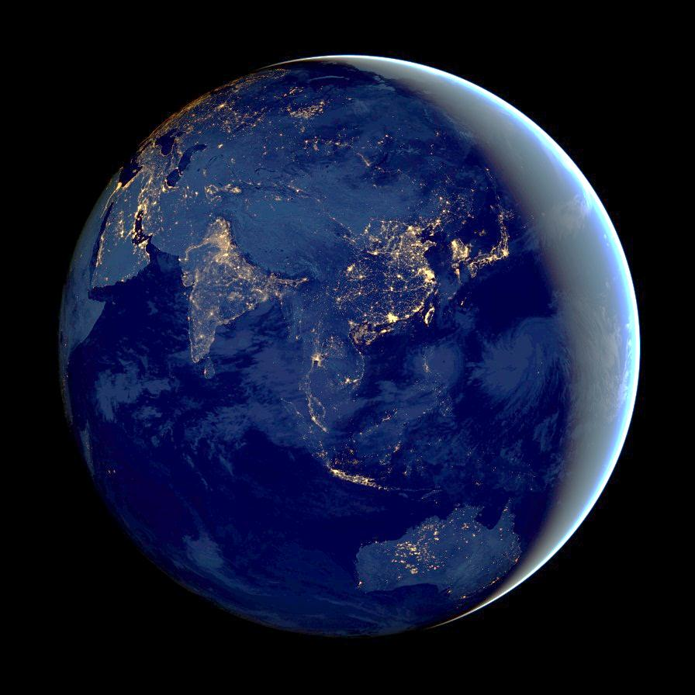

This interdisciplinary course will investigate the interwoven social, cultural, scientific, and technological aspects of the Anthropocene, the geologic age defined by the influence of humans on the planet. Students in the class can expect to develop an understanding of how the Anthropocene is defined, to examine scientific evidence for that definition, and to discuss the scientific and social implications of that definition. The course will also consider technological and social strategies for managing complexity in this new era.

For more information contact Eric Brown: ebrown@umbc.edu