**INDS 430 (Spring 2015)**

**Creating Food System Justice**

**Project-Based Learning**

~~~~**~~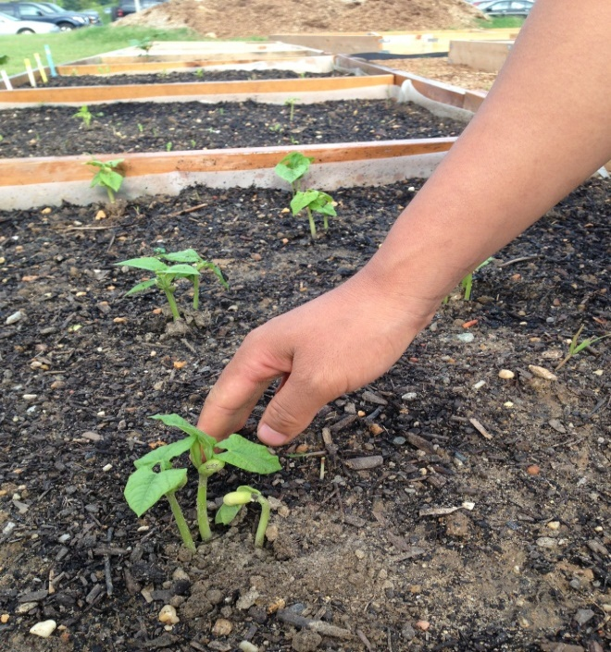~~**

Tuesdays & Thursdays from 1:00-2:15pm

Room: ITE 237

In this class, we will dig -- with our minds and our hands – into issues and projects connected to our local food system to:

* Create, and develop marketing and outlets for, a student microgreen enterprise

* Establish a community garden for refugee families

* Support a new farmers’ market in West Baltimore to improve healthy food access in that community

* Design and install an edible, perennial landscape at the UMBC Garden

* Develop UMBC and K12 partners for a “Climate Change Monitoring Garden”

* Collaborate with the Baltimore Orchard Project’s “Funky Fruit” initiative to recover and create a marketing campaign for locally grown irregular fruits and vegetables that are otherwise disposed as waste.

Permission required for registration. For more information contact Jill Wrigley at [wrigleyj@umbc.edu](mailto:wrigleyj@umbc.edu)