UMBC’s 3K Turkey Trot Registration Form
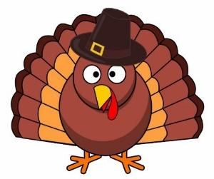
Wednesday, November 16
Starting at 12:15pm
(Please Print Clearly)



Name: ____________________________________________________________

Address: __________________________________________________________

Email: ____________________________________________________________

Phone #:__________________________________________________________
Are You? (Please Check One)
_____ Student _______Staff ______ Faculty
Shirt Size: (Please Circle One)
Small Medium Large X-Large
Age: (Optional) ____________
Gender: _____ Male ____ Female _____ I Prefer Not To Say

***Participants should be aware that there is a risk of injury in participation of Recreation Sports due to the inherent nature of the activity. Individuals are encouraged to have a complete physical examination and obtain adequate health insurance prior to participation in campus recreation and intramural activities. Individuals participate in these activities at their own risk.

Signature: _________________________________________________________________________
For more information please contact Lionel Edouard at the Recreation and Intramurals Office at
E-mail: Edouard1@umbc.edu or Phone: 410-455-3122.

