

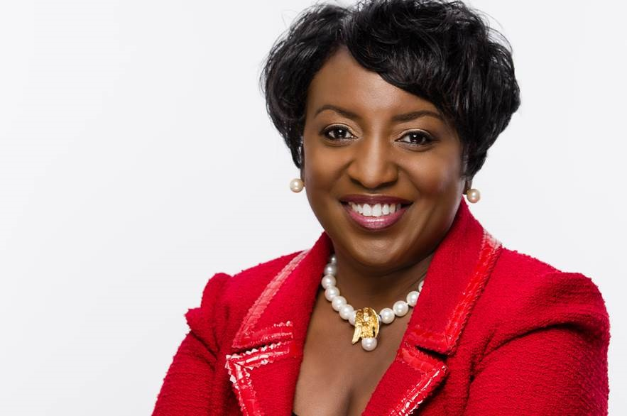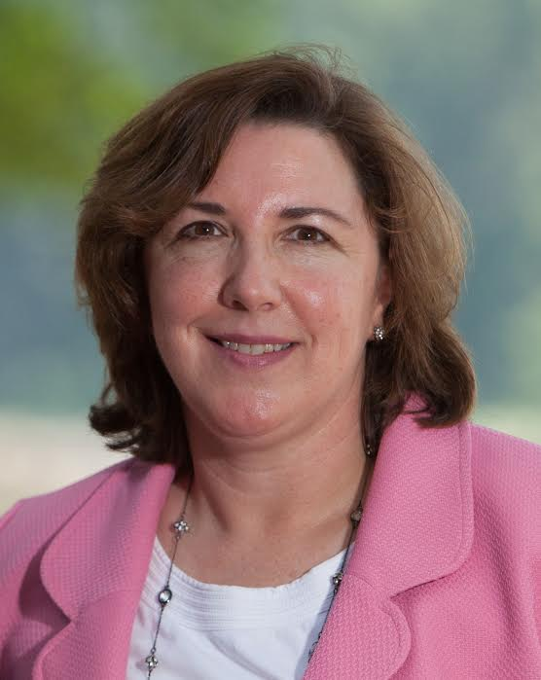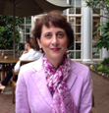

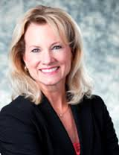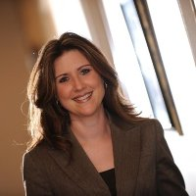

**Why should you attend?**

* Informal Conversation about different paths to leadership.
* Career advice on designing your career.
* Making hard decisions & overcoming failures
* Technical skills vs Soft skills
* Northrop Grumman Recruiters will be there to meet you.

**Agenda:**

* Brief Intro
* Panel
* Audience Q &A
* Eating and Networking

**WHERE:**

University Center Rm 312

**DATE**

Wednesday –November 18th

5:00-6:30pm

* **Belinda Coleman:** President/CEO the Coleman Group Inc.
* **Brenda Martineau :** Organizational Leadership & Management Skill Community Director of NSA
* **Deborah Bonanni:** Former Chief of Staff of NSA & VP of Intelligent Decisions, Inc.
* **Diane Howard:** VP of Cyber Operations of Northrop Grumman
* **Jennifer R. Walker :** President/CEO Resolute Technologies, LLC

Hors d'oeuvres will be served. **|** Feel free to stop by whenever you can. |No dress code.