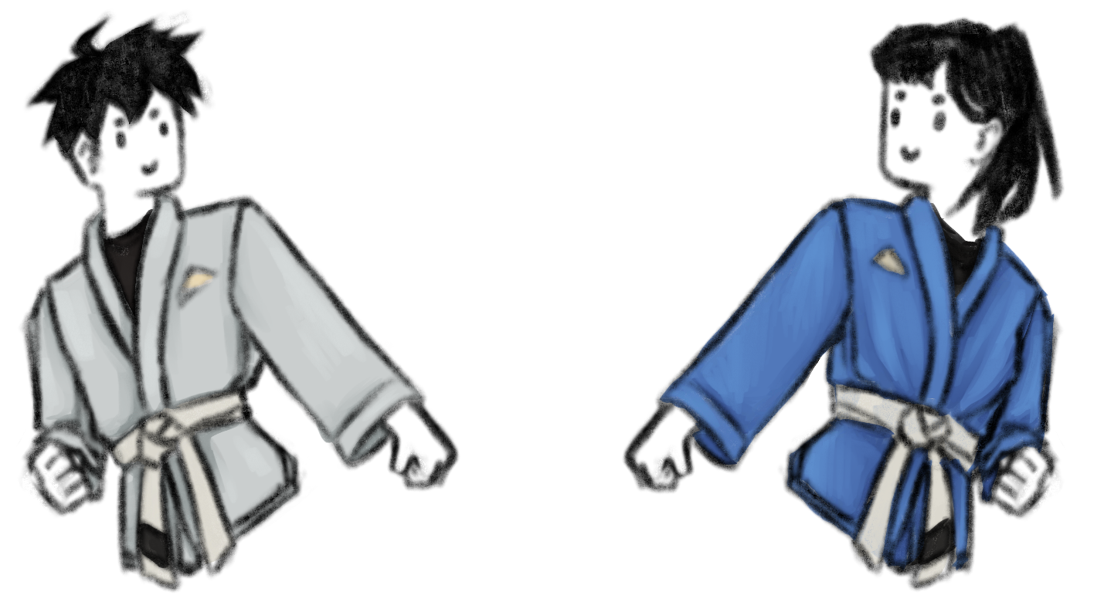

***Before your first Class:***

* Do not eat heavy foods for 30 minutes
* Tie back long hair
* Wear appropriate undergarments
  + Supportive sports bras
  + A sports cup if needed
  + No binders
* Make sure to take care of and cover any papercuts or injuries
* Tell one of the instructors or officers if you have an injury, disability, or condition

**UMBC Jiujitsu Club Welcome Doc**

*In addition:*

* Jiujitsu does require contact, let your partner or one of the instructors know if you are uncomfortable
* Please make sure that your workout apparel is clean and be mindful of your personal hygiene
* Wear athletic clothing that fits well, and you are okay with people touching
* *Do not wear earrings, bracelets, necklaces, and other forms of jewelry*

