In order to allow for tracking of proposals and awards related to COVID-19, OSP will utilize the keyword field in KUALI. The keyword COVID-19 has been established in the keyword drop down in proposal development. For any COVID related proposals please go to the keyword drop down and select COVID-19 (see screenshot below). Specifically as shown below, when creating a proposal, on the 1st page, complete all 7 key fields then ***Press Save and Continue***. On the next screen, you will now see the Key word field. All you must do is select COVID-19. Please also continue entering at the beginning of all titles as that make is more quickly apparent when processing. By adding the keyword, it will ensure easy selection for reporting even if there were to be a typo in the title.

If you have any questions, please contact your OSP Manager.

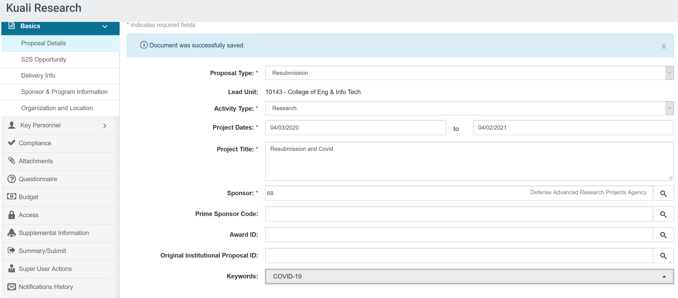

Thank you