|  |  |  |  |  |  |
| --- | --- | --- | --- | --- | --- |
| |  |  | | --- | --- | | **Colonial Latin America**  HIST328  FALL 2024  T-TH 10 AM-11:15AM  Fine Arts 014 |  | | **Course Description and Objectives**  **In this course, we explore the history of Latin America from conquest to independence.**  You will learn about the encounter of three different worlds and how people adjusted to the changes that this encounter unfolded. We will explore how people in Colonial Latin America negotiated, challenged, and resisted the creation of a new sociopolitical order. We will discuss themes such as race, slavery, religion, gender, and politics. You will also develop ways of thinking historically through the critical analysis of primary and secondary sources and craft your own historical | narrative using a variety of sources. Our weekly meetings will include a mix of lectures, discussions, and group work. We will read books and academic articles, listen to podcasts, watch videos, and analyze material objects such as paintings, maps, etc.  At the end of the course, you will understand the chronology of Colonial Latin America and be able to distinguish major changes and trends in the 15th, 16th, 17th, and 18th centuries. Moreover, you will be able to apply critical thinking skills to the analysis and interpretation of a variety of subjects, including ideas, cultural artifacts, or aesthetic works, and construct a cogent argument supported by evidence, articulated judgment, and a conclusion. | | |
| A painting of a person wearing a blue and pink headdress  Description automatically generated  Your instructor:  Dr. Silvia Escanilla Huerta  Office: Fine Arts 521  Email: [silviak1@umbc.edu](mailto:silviak1@umbc.edu)  Office Hours: Thursdays 2:00-3.30PM. Email me if you wish to meet on Webex/Google Meet. |

# Course Requirements

## **Oral and Written Participation and Engagement (20% of grade):**

|  |
| --- |
| Grading Convention: 100 possible points |
| 90-100 points: A |
| 80-89 points: B |
| 70-79 points: C |
| 60-69 points: D |
| Below 60 points: F |

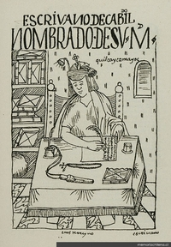Your regular and active participation in group discussions is crucial. I will not lecture for more than 20 minutes in each class, so the rest of the time will be dedicated to listening to lively, respectful, and substantive discussions of the readings. This means you must come to class on time and be ready to share your thoughts about the readings you have done. *Starting on the third week of classes, you will bring your own discussion questions (3-4)* *based on the week's readings to start the discussion.*

**Reading Journal (30% of grade):**

At the end of each week, you will write 1-2 pages in your reading journal, reflecting on the readings and discussions we have had in class. You can list three things you thought were interesting, write about two things that confused you, and ask one question about something you want to learn more about. Alternatively, you can comment on a material object related to the week’s topic, a primary source you find relevant, or view a documentary or movie. Other creative ways involve writing a poem, a drawing, or an infographic related to the material. *Journals are due on Blackboard on Sundays at midnight.*

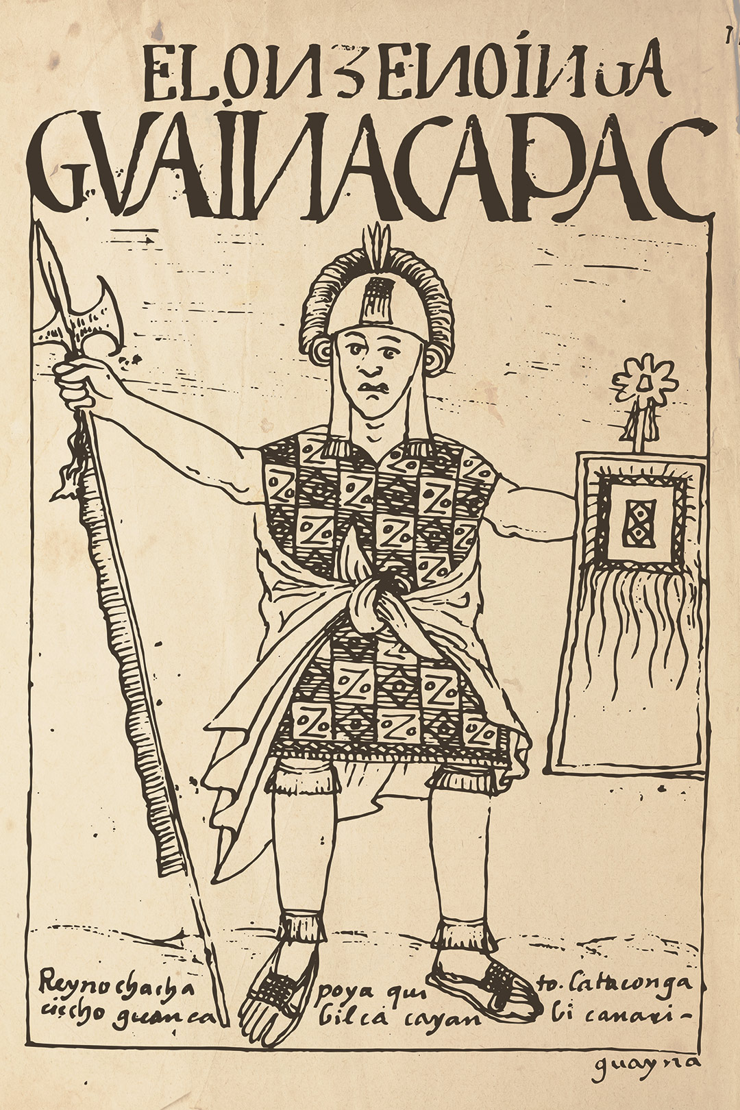

## **Avatar Project (30% of grade):**

The Avatar Project is a unique opportunity for you to delve into the life of a character from Colonial Latin America. You will write a 1600–1800-word autobiographical essay on a character who lived between 1600 and 1800. Your character must be completely fictional but historically accurate, and they cannot change the course of history. The goal of the assignment is to challenge you to think critically about specific events, situations, and dilemmas that people faced in the period and to test your knowledge of Colonial Latin America. You are encouraged to write the essay in the first person, but you can write the story as a dialogue, a journal, as letters, etc. The essay must detail your character’s birth, age, location, occupation, parentage, religion, marital status, and socio-economic status. It should also incorporate 4-5 themes discussed during the course. The narration should cover a 25+ year period, and artistic representations of your A drawing of a person sitting at a desk
character are also welcome. *The essay is due on the last day of classes.*

**Book Review (20% of grade):**

You will write a book review of one of the books suggested on page 5. A good review is 2-3 pages long and gives the reader a concise content summary. This includes a relevant description of the topic and its overall perspective, argument, or purpose. More importantly, a review offers a critical assessment of the content. This involves your reactions to the work under review: what strikes you as noteworthy, whether it was effective or persuasive, and how it enhanced your understanding of the issues at hand. I expect your book review to be free of grammatical and spelling errors and otherwise well-edited. Check the guidelines posted on Blackboard. *The book review is due on October 6 at midnight on Blackboard.*

**The Fine Print**

**Grade Challenges**

If you have a complaint about a grade, I ask that you compose a written description of your complaint and submit it to me with your original graded assignment. This description should justify in specific terms why you believe that you deserve a higher grade. I will consider your request and reply to you in writing. This provides a clear paper trail of our discussion and formalizes your grievance. Grade complaints must be submitted within one week of receiving your graded work back.

**Student Disability Services (SDS)**

The Office of Student Disability Services (SDS) is the UMBC department designated to coordinate accommodations that allow students equal access and inclusion in all courses, programs, and activities at the University. If you have a documented disability and need to request academic accommodations, please refer to the SDS website at sds.umbc.edu for registration information and to begin the process. If you have questions or concerns, you may contact SDS by email at [disAbility@umbc.edu](mailto:disAbility@umbc.edu) or by phone at (410) 455-2459. If you require accommodations for this class, make an appointment to meet with me to discuss your SDS-approved accommodations.

**Statement of Academic Integrity**

Academic dishonesty is a serious matter at UMBC. Cheating, fabrication, plagiarism, and helping others commit these acts are all forms of academic dishonesty, which are wrong. Academic misconduct could result in disciplinary action that may include but is not limited to suspension or dismissal. The complete Student Academic Conduct Policy is available through the Provost’s website: <http://www.umbc.edu/provost/integrity/acc_policy/>

**Absence Policy**

Course grades correlate to attendance. You may have two unexcused absences, but after this, please see me to discuss how to succeed in class.

**Laptop and Phone Policy**

Cell phones are not allowed in class. Laptops are allowed if they display assigned readings and notes from the class or when required by the instructor.

**Title IX/Sexual Misconduct**

Any student who is impacted by sexual harassment, sexual assault, domestic violence, dating violence, stalking, sexual exploitation, gender discrimination, pregnancy discrimination, gender-based harassment, or related retaliation should contact the University’s Title IX Coordinator to make a report and/or access support and resources. The Title IX Coordinator can be reached at titleixcoordinator@umbc.edu or 410-455-1717.

**AI Policy**

Students using AI should be transparent about their use and ensure it aligns with academic integrity.

# **Syllabus**

|  |  |  |  |  |
| --- | --- | --- | --- | --- |
| **Week** | **Topic** | **Date** | **What to Read/Watch/Listen** | **What's Due** |
| 1 | Introductions | Th 8/29 | Syllabus |  |
|  |  |  |  |  |
|  |  | Tu 9/3 | Townsend, *Fifth Sun*, Ch. 3. |  |
| 2 | Pre-Hispanic America | Th 9/5 | Rostworowski, *History of the Inca* *Realm*, Ch. 6 | Journal Entry |
|  |  |  |  |  |
|  |  | Tu 9/10 | Altman, "The Revolt of Enriquillo" |  |
| 3 | Conquest | Th 9/12 | Listen to Prof. Restall: <https://shorturl.at/Qe8t1> | Journal Entry |
|  |  |  |  |  |
|  |  | Tu 9/17 | "Matthew, "Whose Conquest" |  |
| 4 | Incomplete Empire | Th 9/19 | Metcalf, "Possession” | Journal Entry |
|  |  |  | "The Indian Pueblo of Texupa," “Codex Osuna,” “Oaxaca” |  |
|  |  | Tu 9/24 | Listen to Prof. Yanna Yannakakis: <https://shorturl.at/7CZz4> |  |
| 5 | Native Communities | Th 9/26 | De La Puente Luna, "That Which Belongs to All" | Journal Entry |
|  |  |  | "Felipe Guamán Poma de Ayala"/"Description of Work in Potosi Mines/Late 17th Century Description of Potosí"/"Abused Mitayos" |  |
|  |  | Tu 10/1 | Bryant, *Rivers of Gold*, Ch. 1 |  |
| 6 | Black Communities | Th 10/3 | Watch "Zumbi Of Palmares:" <https://shorturl.at/uNh9a> | Book Review |
|  |  |  | "Felipe Edimboro Sues for Manumission" |  |
|  |  | Tu10/8 | Cope, *The Limits of Racial Domination*, Ch. 4 |  |
| 7 | Daily Life in Colonial Latin America | Th10/10 | Watch Prof. Tamara Walker on Colonial Fashion (From 58:32 to 1:28:58) <https://rb.gy/es40sf> | Journal Entry |
|  |  |  | "Drinking, Gambling, and Death on a Colonial Hacienda"/ "Don Manuel Valdivieso y Carrión protests the marriage of his daughter" |  |
| 8 |  | Tu 10/15 | Tavárez, "Autonomy, Honor and the Ancestors" |  |
|  | The Spiritual Conquest | Th 10/17 | Inquisition Documents | Journal Entry |
|  |  |  |  |  |
|  |  | Tu 10/22 | Uribe-Uran, *Fatal Love*, Introduction |  |
| 9 | Gender | Th 10/24 | "Under Investigation for the Abominable Sin" | Journal Entry |
|  |  |  | Abercrombie, *Passing to America*, Pp. 207-216 |  |
| 10 | Enlightenment | Tu 10/29 | Cañizares Esguerra, "Bartolomé Inga's Mining Technology" |  |
|  |  | Th 10/31 | Crawford, *Andean Wonder Drug*, Ch.1 | Journal Entry |
|  |  |  |  |  |

|  |  |  |  |  |
| --- | --- | --- | --- | --- |
| **Week** | **Topic** | **Date** | **What to Read** | **What's Due** |
|  |  | Tu 11/5 | McFarlane, "Reform and Rebellion in Spanish America" |  |
| 11 | Age of Change | Th 11/7 | Listen to SYMIHC: Tupac Amaru Rebellion <https://shorturl.at/S4HUk> | Journal Entry |
|  |  |  | Excerpts from Stavig and Schmidt, *The Tupac Amaru and Catarista Rebellions* |  |
| 12 |  | Tu 11/12 | Watch “Rethinking Latin American Independence Movements” <https://rb.gy/0a5m0c> |  |
|  | The Breakdown of the Imperial Order | Th 11/14 | Eastman and Sobrevilla, Ch. 2. | Journal Entry |
|  |  |  | "Morelos' "Sentiments of the Nation""/"Meltdown in New Spain" |  |
| 13 | Independence | Tu 11/19 | Rabinovich and Soriano, "Public Opinion and Militarization" |  |
|  |  | Th 11/21 | Read my blog entry: <https://shorturl.at/7C2VV> | Journal Entry |
|  |  |  | "Argentine Declaration of Independence" |  |
| 14 | Independence | Tu 11/26 | Watch movie "The Liberator" on Tubi: <https://rb.gy/2akp3l> |  |
|  |  | Th 11/28 | Thanksgiving. No Class |  |
|  |  |  |  |  |
| 15 | The New Republics | Tu 12/03 | Sabato, *Republics of the New World,* Ch.2 | Journal Entry |
|  |  | Th 12/05 | <https://time.com/5662653/democracy-history-latin-america/> |  |
|  |  |  |  |  |
| 16 | Conclusion | Tu 12/10 | Avatar Project due in class. | Avatar Project |
|  |  |  |  |  |

**Textbook (suggested)**: Matthew Restall and Kris Lane (Eds.) *Latin America in Colonial Times*. Second Edition (New York: Cambridge University Press, 2018).

**Books available for book review:**

* Karen Graubart, *Republics of Difference: Religious and Racial Self-Governance in the Spanish Atlantic World* (New York: Oxford University Press, 2022).
* Tamara J. Walker, *Exquisite Slaves: Race, Clothing, and Status in Colonial Lima* (New York: Cambridge University Press, 2017).
* Ann Twinam, *Purchasing Whiteness: Pardos, Mulatos and the Quest for Social Mobility in the Spanish Indies* (Stanford: Stanford, University Press, 2015).
* Di Hu, *The Fabric of Resistance: Textile Workshops and the Rise of Rebellious Landscapes in Colonial Peru* (Tuscaloosa: University of Alabama Press, 2022).
* Paola Revilla Orías, *Entangled Coercion. African and Indigenous Labour in Charcas (16th-17th Centuries*), (Berlin: Walter deGruyter, 2021).
* Camilla Townsend, *Malintzin’s Choices: An Indian Woman in the Conquest of Mexico* (Albuquerque: University of Mexico Press, 2006).
* Tatiana Seijas, *Asian Slaves in Colonial Mexico: From Chinos to Indians* (New York: Cambridge University Press, 2014).
* Lyman Johnson, *Workshop of Revolution: Plebeian Buenos Aires and the Atlantic World, 1776-1810* (Durham: Duke University Press, 2011).
* Barry Robinson, *The Mark of the Rebels: Indios Fronterizos and Mexican Independence* (Tuscaloosa: University of Alabama Press, 2016).
* Alida Metcalf, Eve Duffy, *The Return of Hans Staden: A Go-Between in the Atlantic World* (Baltimore: Johns Hopkins University Press, 2012).

*If you are interested in other topics/authors/books, let me know and we can find alternatives.*