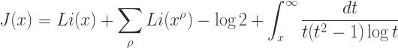
RELAX AND REFUEL
Games,
Drinks, Refuel Snacks,
And More Surprises!
A

A
And More!

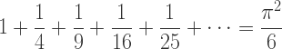

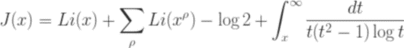
AOK Library Atrium and Gallery December 13th, 2017
12pm-3pm
Sponsors: Counseling Center, University Health Center & AOK Library & Gallery

