University of Maryland, Baltimore County

**Book Talk by author M. J. O’Brien**

**Monday, November 17, 2014**

**7:30 – 9 pm**

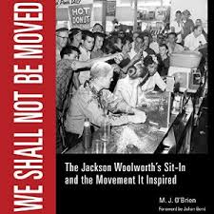

**7th Floor**

**Albin O. Kuhn Library**

Inspired by the iconic photograph on the book cover, M. J. O’Brien tells the stories behind the 1963 sit-in at Woolworths in Jackson, Mississippi. This compelling book chronicles the people and the events of the sit-in and examines its role in the context of the civil rights movement and the subsequent assassination of Medgar Evers. The people in the photograph are brought to life with the perspective of five decades. Mr. O’Brien recently received the Lillian Smith Book Award for 2014 which honors authors who embody Smith's legacy of elucidating racial and social inequity and promoting justice and understanding.

RSVP at <https://www.eventbrite.com/e/we-shall-not-be-moved-book-talk-tickets-13708024069>.

This event is sponsored by the Department of Education and the UMBC Great Books Club.

Image source: University Press of Mississippi.