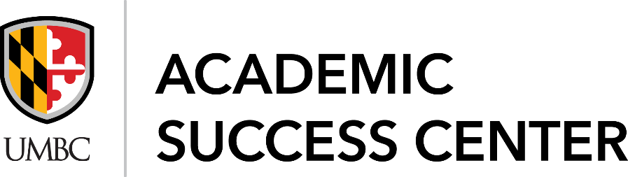
Supplemental Instruction Peer Assisted Study Session (SI PASS)
Program Support Assistant Job Description
Position Title: Program Support Assistant, SI PASS Program
Department: Academic Success Center (ASC)
Reports To: Assistant Director of SI PASS Program
Hours per week: Up to 15 hours a week
Pay Rate: $14 per hour
Background:
The Academic Success Center provides centralized support services to all undergraduate students at UMBC. Through a coordinated approach and an unwavering commitment to student success, the Academic Success Center fosters a welcoming environment that provides a one-stop opportunity through Academic Policy, Academic Learning Resources, and Academic Advocacy for students to achieve their academic goals and claim their future with a UMBC degree.
Academic Learning Resources include tutoring, writing center, academic alerts, placement testing, skill courses, academic success meetings and Supplemental Instruction/Peer-Assisted Study Sessions (SI PASS).
SI PASS is a proactive academic assistance/enhancement program that provides opportunities, via group review sessions and collaborative learning, for students to increase academic performance and to learn how to learn. The SI PASS program targets courses that students perceive as challenging. Historically, many of these courses have been statistically shown to have a 30 percent or higher number of D or F final grades and/or withdrawal rates.
The SI PASS Program Support Assistant will assist with the daily administrative duties of the program including coordinating room scheduling, tracking leader activity and attendance, preparing program reports, updating program forms, surveys, and documentation methods, and disseminating program information to faculty, staff and students.
General Duties and Responsibilities:
The SI PASS Program Assistant, under the direction of the SI PASS Assistant Director, will assist/perform the following tasks:
- Maintain and update SI PASS leader records;
- Observe, evaluate and document performance of SI PASS leaders and provide feedback;
- Regularly meet with the SI PASS Assistant Director to debrief regarding program tracking, reports, leader activity, and scheduling;
- Support the daily operation of the SI PASS Program and ASC;
- Utilize Google Docs and BOX to update/create program forms/documents;
- Other duties as assigned by the SI PASS Assistant Director

Qualifications:
- Bachelor’s Degree
- Models appropriate professional attitudes and behaviors to staff, students, faculty, and others;
- Demonstrates effective oral, written, interpersonal communication skills;
- Exemplary organization and time management skills;
- Can work independently to accomplish job goals;
- Proficient in Microsoft Office Suite and Google Suite (Forms, Sheets, Docs) and BOX.

Preferred Qualifications:
- Served in an academic support area such as Supplemental Instruction or Tutoring for at least one year;
- Adept in PeopleSoft software and myUMBC Groups;
- Experienced in students with disabilities accommodations, based on college policy and government regulations.

Application is through UMBCWorks (job ID #9328514)

