International Conference on Language Policy and Multilingual Education: Mandalay, Myanmar, 7 – 9 February, 2016
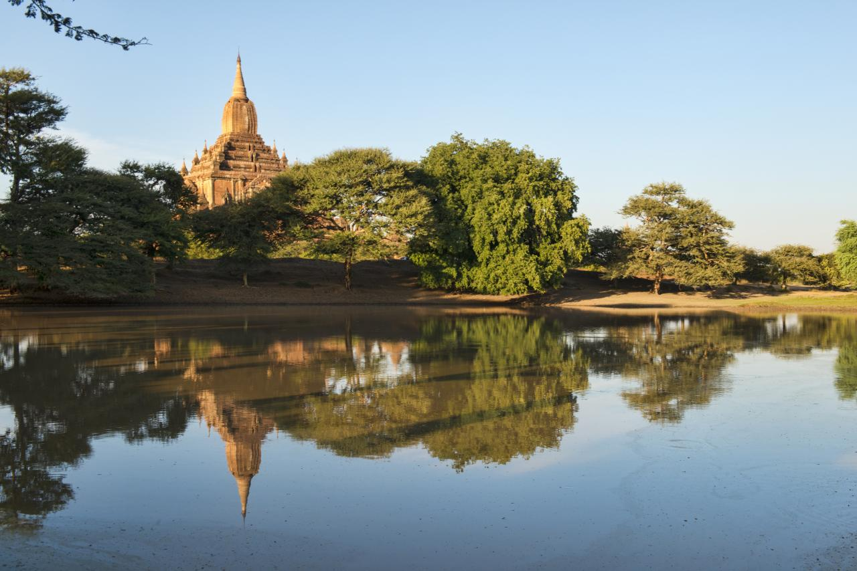
First Call for Papers and Conference Announcement
Key Dates:
Closing date for submission of proposals: Friday 30th October, 2015
Notifications of acceptance: Friday 27th November, 2015
Last date for speakers to confirm participation: Friday 25th December, 2015
Conference: Sunday 7th – Tuesday 9th February, 2016
Convened by Professor Joseph Lo Bianco

Introduction to the Conference:
As part of the UNICEF/University of Melbourne Language, Education and Social Cohesion project, a major International conference on language planning and multilingual education is being held in Mandalay, Myanmar on February 7-9, 2016. The organisers invite scholars, practitioners, language and cultural groups, school and university planners to submit abstracts on multilingual education, language policy, social cohesion, and peacebuilding themes to participate in this inaugural conference. The organisers look forward to your participation in this exciting opportunity to deepen understanding, share experiences and discuss progress in language policy and multilingual education. Distinguished international and local speakers will present papers on critical issues and developments. Official representatives from across Southeast Asia will report on the state of multilingual education and language policy in diverse countries. In addition to the plenary speakers, the conference invites local actors including advocacy representatives, government officials, teachers, community members, and academics to present on any aspect of multilingual language policy and its implications in Southeast Asia and more widely.

Objectives

To examine the role of multilingual education planning and policy in:
- the development of Indigenous languages and cultures in diverse, multilingual societies;
- the development of social cohesion;
- the advancement of economic development and social justice.

Submission of proposals

- Single Paper Presentations:
These will consist of 30 minute sessions, 20 minutes for presentations followed by 10 minutes of questions and discussion. Abstracts should not exceed 250 words and can be submitted in either English or Myanmar. Submissions will be selected based on their relevance to the conference themes, as well as for the clarity of ideas and argument. Preference will be given to papers that report new findings, new sites of research, and innovations in either language use research, teaching methodology, script or language planning issues. Submissions close Friday 30th October, 2015, and notifications of acceptance will be sent on Friday 27th November, 2015.

- Panel Presentations:
If you wish to propose a panel you need to supply the organising theme of the session. Please include the names of all presenters, the titles of their individual contributions and the order of their presentations. Panel duration is a maximum of 2.5 hours.

For submissions:
Please send all abstracts and proposals to MyanmarNLP-conf@unimelb.edu.au
Please include:
- Name
- Affiliation
- Email address
- Paper title
Abstracts are not to exceed 250 words and should include keywords to assist with program allocation. Please see the conference website program page for guidance on conference themes by clicking on the following link http://www.myanmarnlp-conference.com/#!program/c11m7

Scholarships and other support for participation
A number of scholarships and other financial and non-financial support for participation may be made available by UNICEF. This will not only be available to presenters but could be provided to support participation in the conference. The funds and other assistance will be for travel, accommodation and miscellaneous expenses. Confirmation of the financial support and the specific arrangements and criteria will be forthcoming and will be posted on the conference website.

The official languages of the conference will be English and Myanmar/Burmese.

