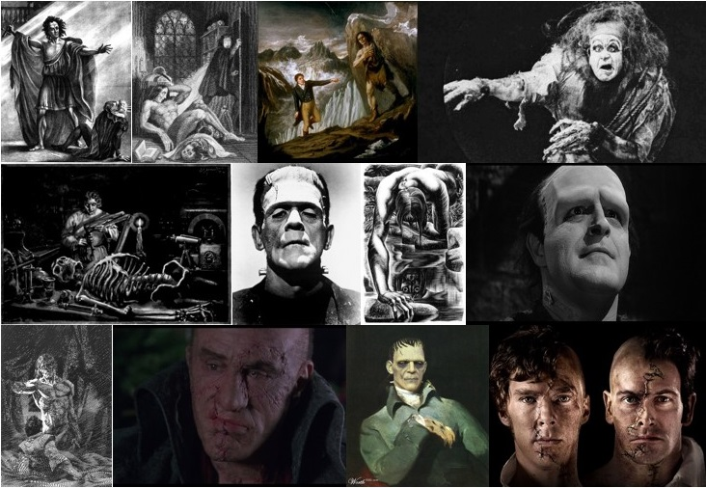

Morgan State University • April 12, 2018

Call For Papers

2018 marks the 200th anniversary of the publication of one of the most influential works of British literature. Mary Shelley’s Frankenstein has been the subject of interpretation from every critical perspective, from Marxism to Psychoanalysis and Gender Studies to Critical Race Theory. Since its original publication, stage and film adaptations have been legion, from Presumption in 1823 to James Whale’s classic 1931 adaption and on through Abbott and Costello, the Hammer Films productions of the 1950s to ’70s, and more recent versions by Kenneth Branagh, Benedict Cumberbatch and Jonny Lee Miller, and Daniel Radcliffe. Beyond the realm of the creative arts, though, Frankenstein has entered the public psyche as a symbol of humanity’s disruption of the perceived natural order. References to this story can be found in discussions of bioethics and genetics, race relations, politics, religion, and foreign policy.

Upon the occasion of the novel’s bicentennial, papers are solicited for a one-day interdisciplinary symposium to be held on the campus of Morgan State University in Baltimore, Maryland. Presenters are encouraged to explore the continuing impact of the novel and its associations in today’s society. Please consider examining this theme through the perspective of any of the following disciplines:

- English or American Literature
- Philosophy
- Business
- Biology
- Chemistry
- Political Science
- Sociology
- Anthropology
- Computer Science
- Women’s and Gender Studies
- Economics
- Fine and Performing Arts
- Health and Physical Education
- History
- Geography
- Medical Technology
- Multimedia Journalism
- Social Work
- Psychology
- Public Health
- Screen Writing and Animation
- World Languages

Please submit 250-word abstracts as MS Word attachments to adam.mekler@morgan.edu by October 1, 2017. Both faculty and students are encouraged to submit and participate.
Please feel free to visit our website: http://l-adam-mekler.com/reading-frankenstein.htm

