**Full-time Graduate Assistant Job Announcements**

**Department:** Sherman Center for Early Learning in Urban Communities

**Department Description:** The multidisciplinary Sherman Center for Early Learning in Urban Communities (Sherman Center) was established to advance George and Betsy Sherman’s vision of improving learning experiences and outcomes for young children in Baltimore City. To achieve this mission, the Sherman Center connects theory, research, and practice, and schools, families, and communities to promote the educational success of children ages three through eight.

# GA Title: Sherman Center Research Assistant*

**Description of Duties:**

This graduate assistant will assist Sherman Center faculty and staff with research-related tasks.

Research Responsibilities

* Provide support for the completion of research projects
* Develop and maintain Sherman Center research databases and conduct basic data analysis
* Assist current full-time faculty with literature review, data entry, and data compilation as required
* Assist faculty and staff with the preparation of research presentations and manuscripts
* Assist faculty and staff with research grant proposal development and submission

*Prior research experience required

# GA Title: Sherman Center Program Assistant

**Description of Duties:**

This graduate assistant will assist the Sherman Center Program Coordinator to carry out several roles within the program:

# Program Responsibilities

* Provide office support for Sherman Center staff
* Assist with event and meeting planning and implementation
* Assist with the organization of Sherman Center files and databases
* Assist with Sherman Center evaluation activities
* Assist in the development of new Center initiatives

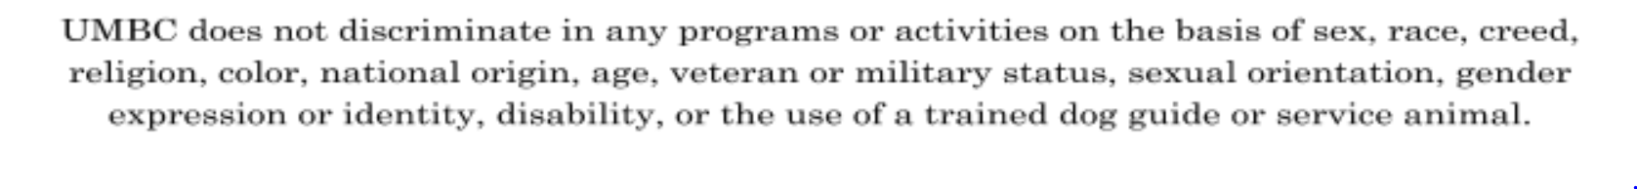

**Application:**

# Masters and doctoral students are encouraged to apply. Please complete the following application and return it and a current resume to Sherman Center Director, Professor Mavis Sanders, via email at msanders@umbc.edu by Friday, August 24, 2018. Interviews will be conducted between Monday, August 27 and Wednesday, August 29, 2018. Selected GAs will be notified by Friday, September 1, and offer responses will be required by Monday, September 4, 2018.

# Full Name:

# Academic Program:

# Academic Standing (Year):

# Cell Phone Number:

# Email Address:

# What is the best way to get in touch with you?

# Please indicate your availability for a 45-minute interview between Monday, August 27 and Wednesday, August 29, 2018 by listing ALL days and times you are available between 10 am - 4 pm.

# 

# Short Answer Questions:

# Please answer the following questions briefly AND in a way that allows us to get to know you, your aspirations, and your motivations.

# What motivated you to apply for this position?

# What characteristics make you uniquely qualified for the position

# Describe your future goals. How would this experience support those goals?

# Please email your resume along with this application to msanders@umbc.edu.