**Facilities,**

**Blue Lights.**

All blue light emergency phones with lights out have been repaired. The dim light at the Freshman parking lot received a new bulb.

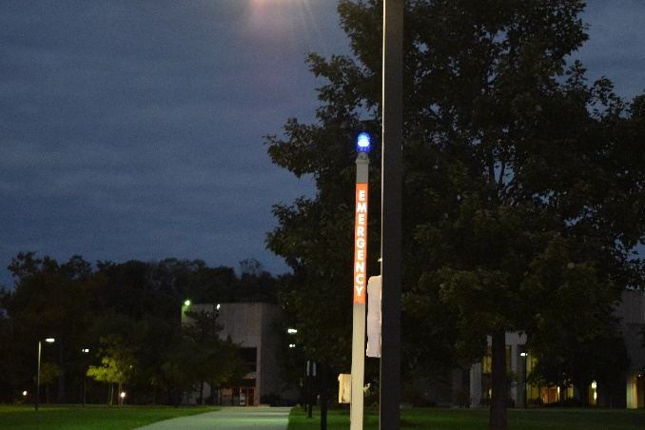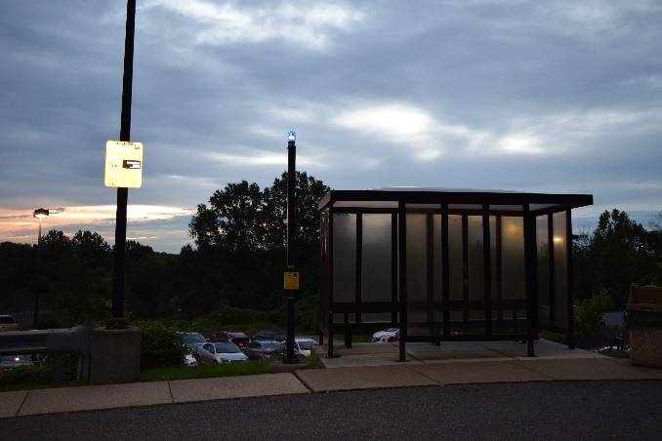

**Lights sections with multiple lights not functioning.**

- The light string on the outside of Hilltop Circle leading to the athletics fields were not operational.

Repaired on 03 October.

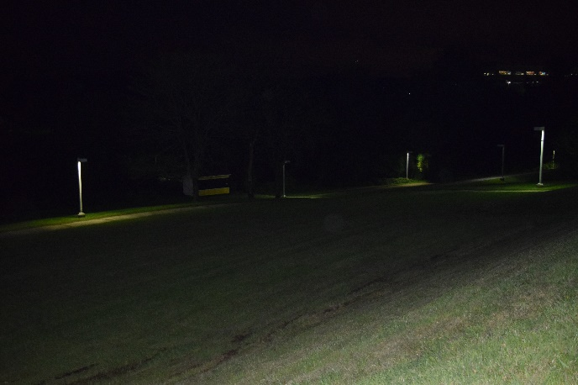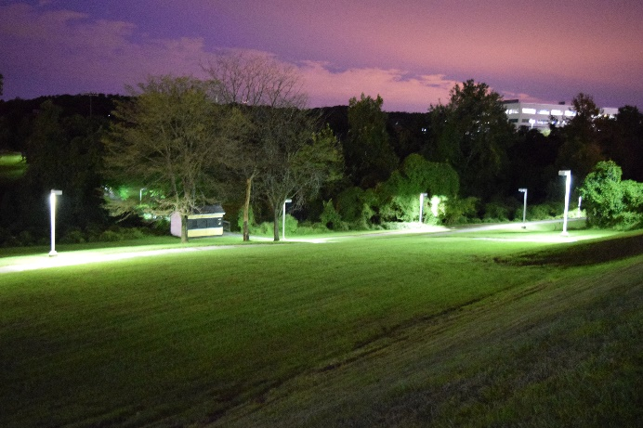

- Two lights just in front of Commons Garage were not operational.

Contractor will repair these two lights by 2 Nov.

- A student mentioned that there are no lights functioning on top of Commons garage.

Commons garage top parking deck has a short circuit and will be repaired by FM’s electricians by 19 October.

- Multiple lights from multiple systems between academic core buildings are out.  Specific areas of concern next to Fine Arts, between Myerhoff and the UC as well as the Myerhoff courtyard stairs.  Lighting systems between all academic core buildings will be evaluated.

**Chemistry**: courtyard poles and stairwell lights were repaired on 05 October.

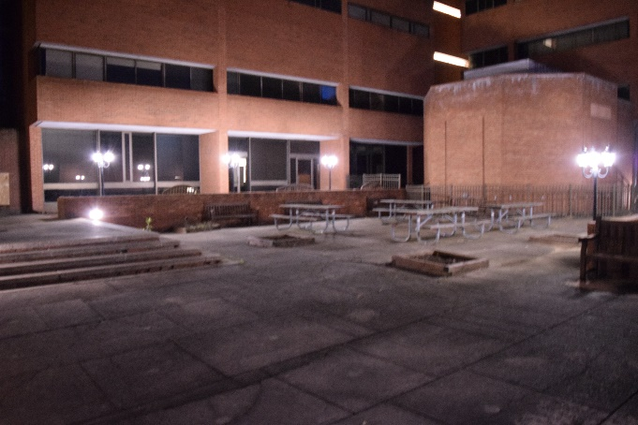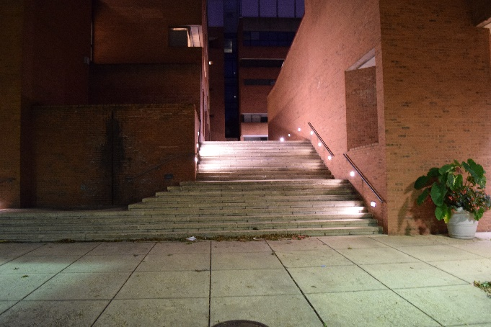

**University Center**: Various outdoor lights will be completed by 12 October.

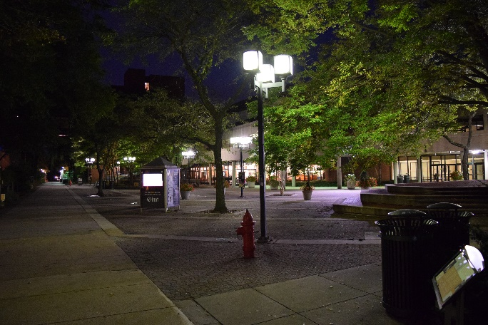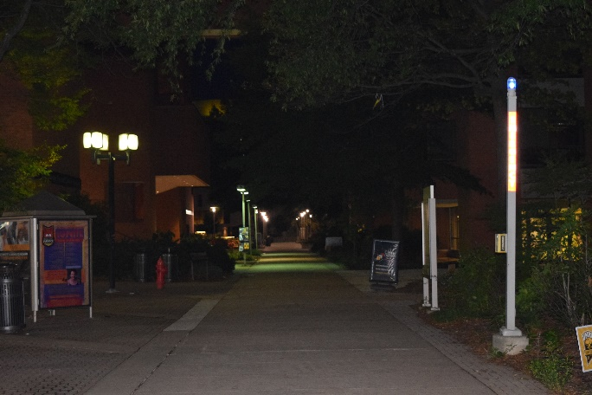

**Fine Arts**: Lights near entry and seating area will be repaired by 12 October.

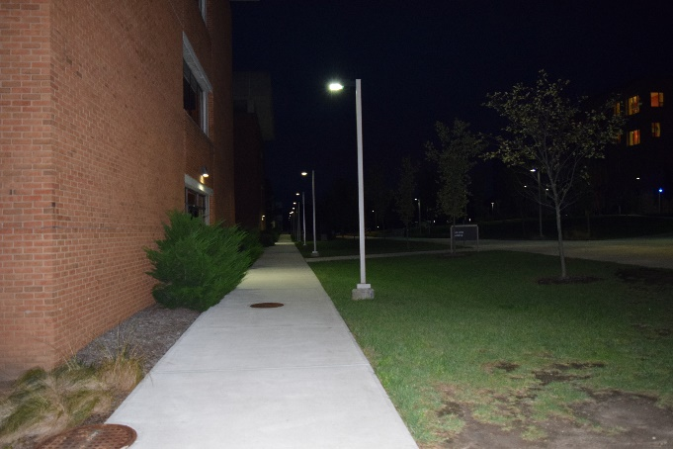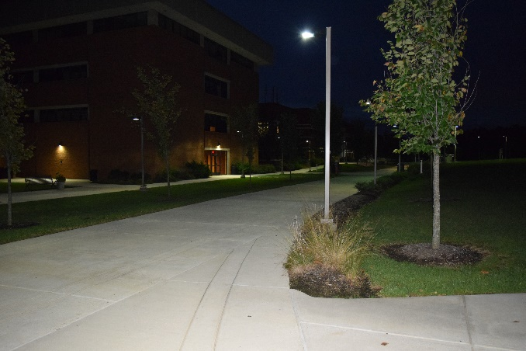

**ECS**: Pole lights are illuminated. The Pedestal lights are unserviceable. FM will take light measurements in this area and if pole lights are providing adequate illumination, we will remove the pedestal lights. Light readings to be taken next week.

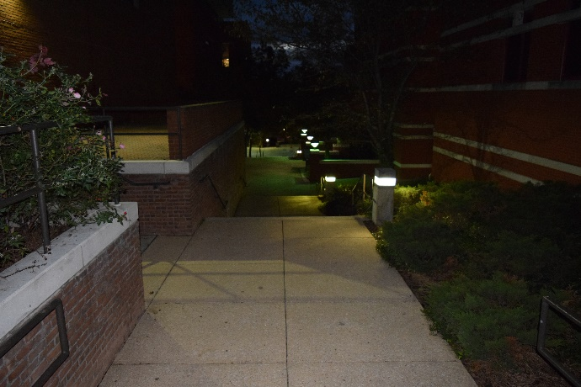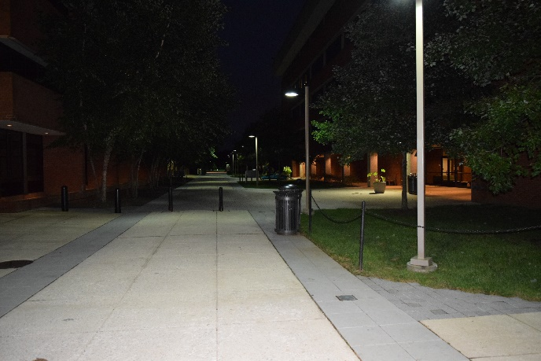

**Sherman Hall**: Lights in the courtyard were repaired on 09 October.

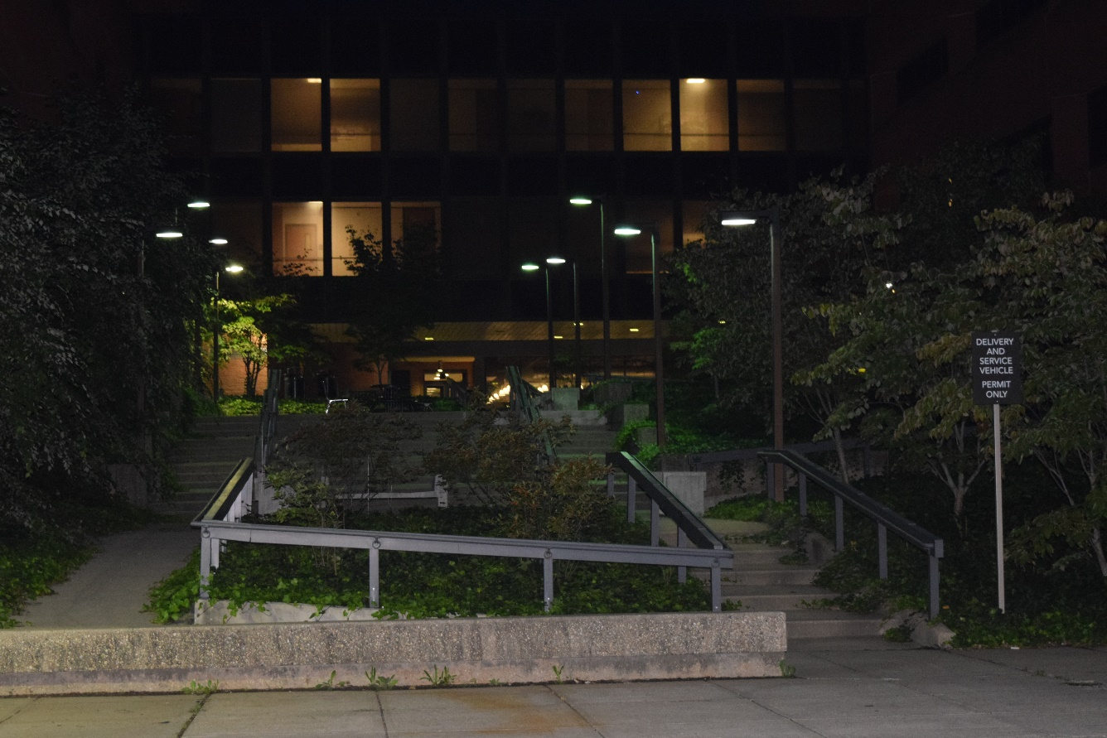

- A student mentioned that the TRC lights on the front side of the building are not functioning.

TRC: ALL lights are lit except one LED light mounted on the wall of TRC. Parts are on order and will be repaired by 02 November.

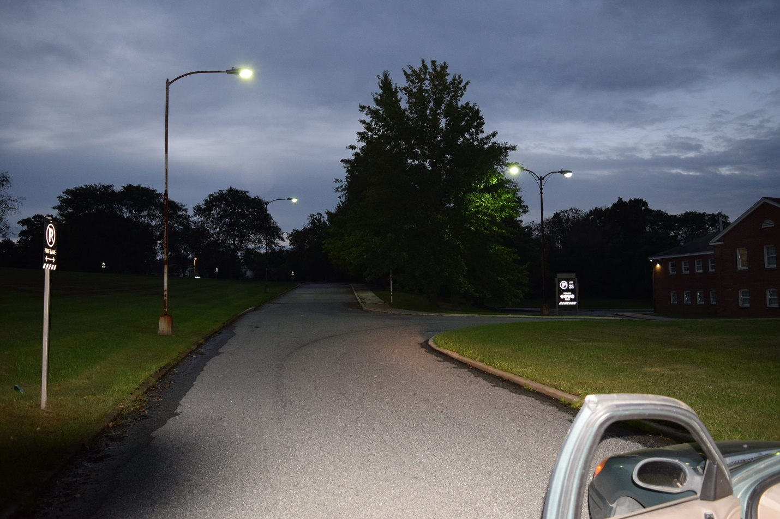

**Areas that appear to have insufficient lighting.**

Center road has lights that are alternated and spread far apart.  Lights are also high and partially blocked by trees.  What can be done to improve lighting in this area short term?

Center Road lighting will be completely relamped with LED lamps in an effort to double the lumen output. Research on appropriate LED bulbs is occurring now. Test bulbs will be installed in a few fixtures at the end of October or beginning of November. Relamping of every fixture will occur just after Thanksgiving.

**Multiple misc lights out throughout the campus**.  Single lights out due to bulb failure are addressed on a continual basis and receive priority when the single bulb failure creates an unacceptable shadowed area.  Single bulb failures are identified with monthly night lighting checks as well as by trouble calls made to work control and are corrected as quickly as workload allows.

Individual light bulbs will continue to be replaced with priority given to areas where multiple bulbs are out and areas where the lack of light creates unacceptable shadows or dark spots. Over 7000 exterior lights on campus.

**Lights in residential areas.**

- Basketball court lights need the timer checked to ensure they remain lit until 10pm.  Seems dark in the area when the court lights are off.

All time clocks are being checked and set for daylight savings time, all time clocks will be checked by 19 October.

- Lights out in front of Erickson Hall and the Library

Lights in front of Erickson Hall and the Library have been relamped.

**Sections of Campus with no lights installed.**

- Westland Blvd (road between TRC and Poplar ave) has no sidewalk or lights.

- Road from stadium lot up to the soccer field has no sidewalk or lights.

- Hilltop Road only has lights and a sidewalk on one side of the road and the opposite side allows parking but has no sidewalk or lights.

- Hilltop Circle between the Admin building and PAHB does not have lights along the sidewalk on the exterior of the circle.

All of these areas are already included as part of FM’s future lighting projects for consideration.

- Walkway along wooden path leading to the research park has no lights.

This area does have a low voltage system that lights the lower walkway surface. This is an Orioles nesting area and additional lighting in this area may not be allowed. FM is revisiting the restrictions on lighting in this area to determine if we can increase lighting levels above what is currently installed.