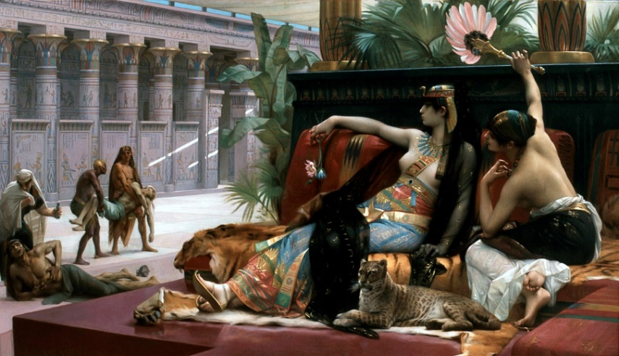
Ancient Studies Week
October 5-8, 2021

Tuesday, October 5th, 10am-6pm, PAHB Forum
‘Homerathon’: A Reading of Selections of Homer’s Odyssey. If you would like to read, please contact Dr. Kutner (mabailey@umbc.edu).

Wednesday, October 6th, 7-9pm, PAHB 132
Aristophanes’ Lysistrata, Student and Faculty Reading of the Play
Limited in-person capacity. If you would like to attend, please email Emily Hubbard ehubbard@umbc.edu. If you are interested in reading, please contact Dr. Rosenbloom (dsrose@umbc.edu).

Thursday, October 7th, 4pm, AOK library gallery
ANCS Week Keynote Lecture by Dr. Duane W. Roller, Professor Emeritus of Classics, Ohio State University, “Cleopatra: the Most Famous Woman of Classical Antiquity.” Co-sponsored by the Dresher Center for the Humanities. For more information, visit the web page https://dreshercenter.umbc.edu/events/upcoming/current-humanities-forum/event/95190/.
Limited in-person capacity. If you would like to attend, please email Emily Hubbard ehubbard@umbc.edu. The lecture will also be live-streamed.

Friday, October 8th, 11am-2pm, PAHB 2nd floor Lobby
Exhibition of the Department of Ancient Studies’ Spiro Collection of Antiquities

Image: Alexandre Cabanel’s Cleopatra Testing Poisons on Condemned Prisoners

