Dept. of Modern Languages, Linguistics, and Intercultural Communication

proudly presents:

“Laugh for Other Men”: Migration, Sex and Race in the French Empire, 1919-1946

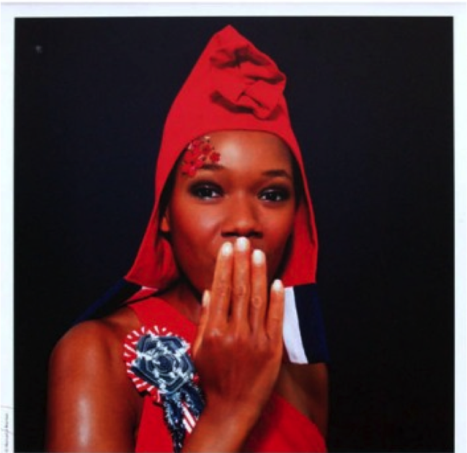

by

Dr. Jennifer Anne Boittin
Associate Professor of French, Francophone Studies, and History
The Pennsylvania State University

Monday 22 September 2014
6:00 - 7:30 p.m.
ITE Building, room 456
Everyone is welcome!

Thank you to all of our co-sponsors for their generous support:

UMBC French Club, Center for the Advancement of Intercultural Communication (CAIC), Gender and Women’s Studies, Global Studies, Sociology & Anthropology

