The Humanities Forum celebrates

Hispanic Heritage Month

Harvest of Empire: The Untold Story of Latinos in America

with Eduardo López

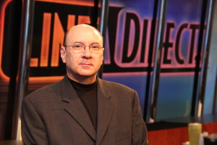
Thursday, September 17, 2015
5:30 PM - 6:30 PM
Performing Arts and Humanities Building -132-
The rapid growth of the nation's Latino community has sparked heated national debate over immigration, yet the reality is that many of us know little about the Latin American roots of migration. In this talk, based on his award-winning documentary, Harvest of Empire, Eduardo López examines the direct connection between the long history of U.S. intervention in Latin America and the immigration crisis we face today, unveiling a moving human story that is largely unknown to the great majority of citizens in the U.S.

Eduardo López is a television producer, journalist and documentarian based in Montgomery County, Maryland

Sponsored by the Dresher Center for the Humanities; Latino/Hispanic Faculty Association; the Modern Languages, Linguistics, and Intercultural Communication Department; the American Studies Department; and the Media and Communication Studies Department.

