Lalo Alcaraz, political cartoonist, @ the UMBC Proscenium Theatre, PAHB

September /26, 7:00pm

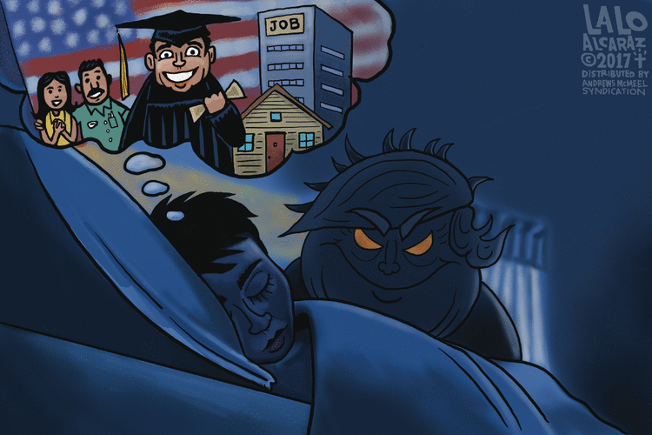

I studied Art & Environmental Design, and this led me to want to save the world through architecture, so I applied and got in to UC Berkeley's Master's of Architecture program. Here, I learned to draw buildings in perspective, and perfectly straight lines, and to perform in front of building takeovers and other protests. I started an agitprop sketch comedy group called the Chicano Secret Service, and also a 'zine called Pocho Magazine. These extracurricular activities would become the core of my future, non-architectural career. After some applause, I had the realization that I had to go back to my original pseudo-plan - become an artist.

After graduation, I moved to Los Angeles to try to get into Hollywood. Then the L.A. Riots happened, and I was invited to create a comic panel for the LA Weekly. I called it L.A. Cucaracha. My comics ran in that rag alongside Matt Groening's Life In Hell and other altweekly comics for 17 years. During that time I developed editorial cartoons for daily papers and became syndicated with this here syndicate. I was asked by a couple of syndicates if I might be interested in developing a daily strip, and only the daring and brilliant folks here at Universal fell for my pitch, and La Cucaracha was born.  […]

Before I was a proto-supervillain, I was a fledgling child cartoonist on the border hinterlands of San Diego, California. My parents were Mexican immigrants from Sinaloa and Zacatecas, two now hot spots for tourist fun. I grew up seeing how sometimes unfairly and harshly they were treated by their American bosses, and I grew angry because of it. This grew into a desire to write and draw things that stood up for the rights of immigrants, Mexican or otherwise.

Drawing and art-making runs in my mom's side of the family's veins, and so I was able to eventually use that gift to express my angry feelings, and develop that into a semi-lucrative career of poking fun at powerful a-holes.

Like every other editorial cartoonist, I was the cartoonist for my college paper, San Diego State's Daily Aztec, during the gaudily colored '80s. My nickname at the paper was, I kid you not, "Please Forward My Hatemail." It was the Reagan Era, and a wonderful time to skewer conservative politicians.

**Lalo Alcaraz in his own words** [May 22, 2015, excerpts]**:**

Hello readers, I am writing to you direct from the top-secret Cucaracha World Headquarters, deep inside the bowels of a Mexican piñata party store somewhere in the Greater Eastside of Los Angeles. From here, I run all of my cartooning operations, satirical writing missions and a pretty lucrative quinceañera bouncer/DJ business. My uniformed staff watches over a bank of monitors in Mission Control as they monitor and report back to me the events of the day, or the whereabouts of Ted Cruz, my fallback instant source of satire and Latino-adjacent mirth.

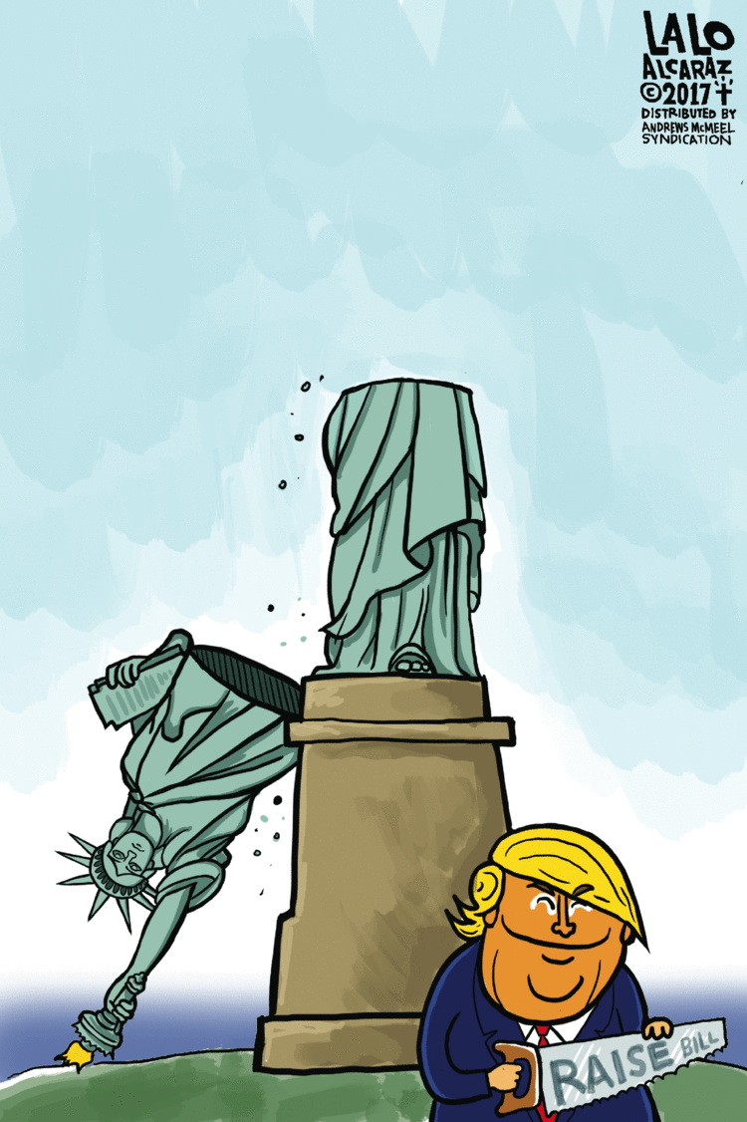

I've been doing La Cucaracha [now a syndicated daily comic strip] since 2003, and it has developed from a primarily social satire strip to a political strip. Read my hate mail and you will see how political things have become.

I do have other paths I have been following, including illustrating books with my academic homie Ilan Stavans from Amherst College in Massachusetts. […] Speaking of television, I am currently consulting producer and writer for an upcoming animated television show [in the] Fox lineup, and that show is called “Bordertown” [2016) […] [Alcaraz is currently a consultant on the upcoming Day of the Day-themed animated Pixar movie *Coco*].

I see from the massive banks of monitors in my studio/lair that my space in this post is up, so let me get back to my many deadlines and side projects. Bootleg SpongeBob piñatas don't make themselves. Adios! - Lalo http://www.gocomics.com/news/between-the-panels/3002/lalo-alcaraz-la-cucaracha-editorial-cartoonist

[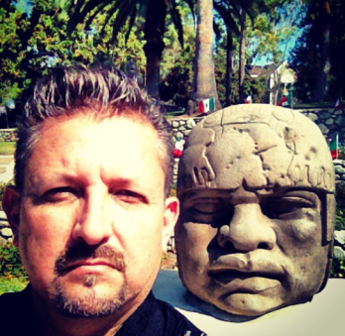](http://gocomics.typepad.com/.a/6a00d8341c5f3053ef01b8d1185b93970c-pi)

[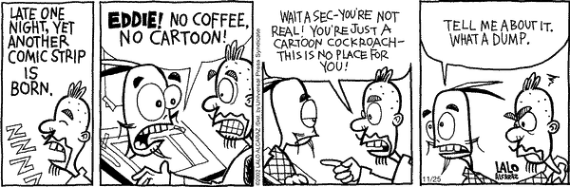](http://www.gocomics.com/lacucaracha/2002/11/25)

