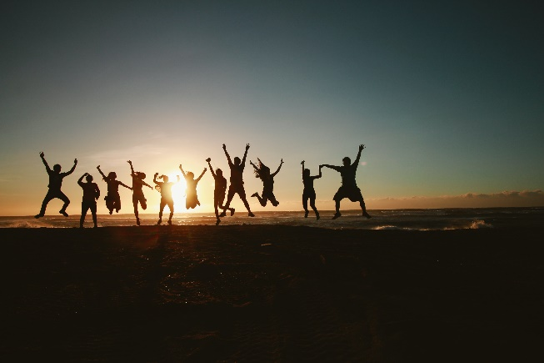  
  
**10/10/22 STAFF DEVELOPMENT COMMITTEE AGENDA**

* 10/26 Welcome to UMBC
  + 81 attendees thus far
  + Logistics & catering
    - Chartwells: desserts, a couple savory things, drinks, etc.
    - Musician lined up
    - Balloons ordered
    - Give away: tote and charger with stand
  + One final marketing push this week!
  + All hands on deck day of
    - Senate members to facilitate name badge activity
    - Registration
    - Mingling
      * What made you come to UMBC? What made/will make you stay?
  + HR to work together on expanding orientation - creating new employee culture/engagement session, buddy system, etc.
* Retriever Talks:
  + Save the Date: 5/17 Time TBD…
  + Preferred Space: Recital Hall
  + Goals: develop our people, engage our community, share our story
  + Talks linked to theme tracks: extend beyond, explore every angle, reach together, claim your future
  + 8 speakers, mix of faculty staff, exempt and non-exempt, diverse perspectives – directors and below
  + 12 week program – 90 min every week (week of Feb 6th- dress rehearsal May 16th) + bi-weekly coaching
  + Even format: 2 hours: 10 minute talks + Q&A at end + reception
  + Live music?
  + Who will introduce tracks/speakers?
  + Staff Development Committee role: market event, choose speakers, event planning/coordination, etc.
  + Timeline:
    - Marketing up by October
    - December 1st: talk submissions in
    - December 12th: review and determine speakers, communicate to all speakers
    - January: speaker social (previous and new class) + prep (schedule calendars, access to shared drive, etc.)
    - Begin cohort week of Feb 6th
  + Need a theme for the event:
    - Something acknowledging the changes we're experiencing and our hopes for the future?
    - Breaking chains binding us
    - Marginalized populations.
    - Staying your course in a time of change
    - new identity, hope, change
    - how change transforms us
    - moving from polarization to unity – similarities in a polarized world
    - unity and freedom
    - Gratitude for our past and aspirations for an even more inclusive community
    - redefine ourselves, work, life, etc.