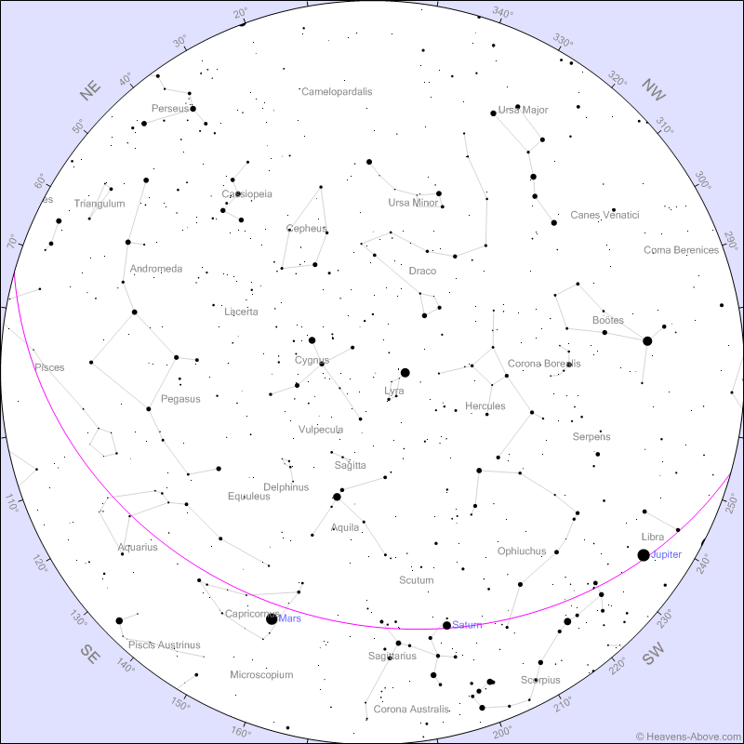

Sky Chart for the Evening!

Will best match the sky above UMBC on January 11th at 8:30pm

Stars will be approximately accurate each day around 8-9pm through January 26th

**(Purple line is Ecliptic Plane)**

**UMBC Observatory Open House**

January 11th, 2019 7:30pm in PHYS 401

**STARS**