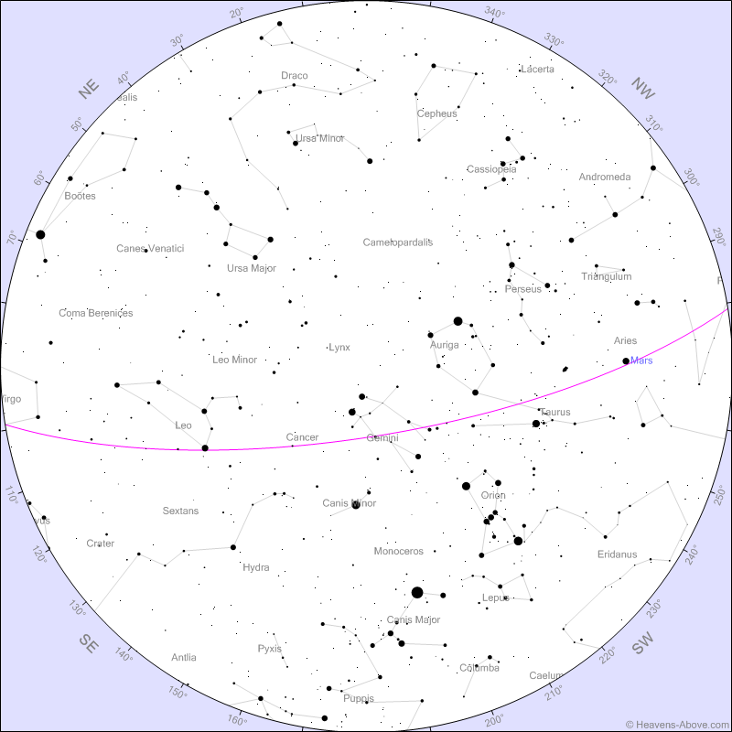

Sky Chart for the Evening!

Will best match the sky above UMBC on March 8th at 8:30pm

Stars will be approximately accurate each day around 8-9pm through March 23rd

**(Purple line is Ecliptic Plane)**

**UMBC Observatory Open House**

March 8th, 2019 7:30pm in PHYS 401

**International Space System**