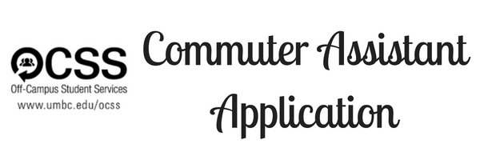

The Office of Off-Campus Student Services (OCSS) seeks motivated, passionate, hardworking, and ethical students to employ as Commuter Assistants (CAs) for the Spring 2017 semester. CAs will serve as advocates for commuter students on the UMBC campus, and they will assist with the retention of these students through the planning and implementation of intentional and impactful programs and events. CAs will also assist with administrative work within the OCSS office.

**Commuter Assistant Duties**

* Plan and implement programs that address the needs of commuter students
* Represent OCSS by sitting at the front desk and answering student, staff and visitor questions
* Serve as a role model to UMBC students and develop a sense of community among

commuter students.

* Assist with OCSS events as needed, including but not limited to, Welcome Week and Commuter Week

*Commuter Assistants must maintain a 2.5GPA prior to and during employment with OCSS.*

**Training and Weekly Time Commitments**

* CAs must attend training sessions prior to the start of the semester(January 25-27, 2016)
* CAs work an average of 10 hours per week, including attendance at weekly team meetings

on Fridays at 12pm.

* **If you are unable to attend training or the weekly team meetings (Fridays at 12:00pm), you cannot serve as a Commuter Assistant.**

**Application Deadline**

Applications must be submitted to OCSS by Friday, November 18th at 5:00pm.

**Contact Information**

For questions regarding the Commuter Assistant application process, please contact Katie Weir, Coordinator for Commuter Engagement, at [kweir@umbc.edu](mailto:kweir@umbc.edu).

**Off-Campus Student Services**

**Commuter Assistant Application***SPRING 2017*

**PLEASE TYPE OR PRINT CLEARLY**

**PERSONAL INFORMATION**

Name:

Primary Address:

Cell Phone #:

Current UMBC GPA: ____

Former College (if applicable): _______________________________________________________________

UMBC ID: _________________________

Polo Size (Circle): SMALL MEDIUM LARGE XLARGE XXLARGE

**EDUCATIONAL INFORMATION**

Including this semester, how many semesters have you been at UMBC?:

Number of credits completed:

Number of credits planned for Spring 2017: ­

Major(s) :____________________________ Minor(s):

Class/Year (Circle): FR SOPH JR SENIOR

Application continues on next page.

**TIME AVAILABILITY**

What days/hours are you available to work (Monday-Friday, 9am-5pm) during the Spring 2017 semester?

Monday:

Tuesday:

Wednesday:

Thursday:

Friday:

**As a Commuter Assistant, you will be required to attend the following events:**

*Friday Team Meetings from 12pm-1pm*

*Commuter Connections on the first Friday of every month from 12pm-1pm*

*Good Morning Commuters Breakfasts on Tuesdays from 8am-10:30am*

I am available to work the schedule above: _____ yes ______ no

**ACTIVITIES AND EXPERIENCE**

Please attach with this application a typed detailed resume describing your involvement in extracurricular clubs and organizations, as well as any work experience. Be sure to specify leadership positions held where appropriate, and list any honors or awards received. Please

include organizational involvement at any former college.

Application continues on next page.

**PERSONAL PERSPECTIVES**

Respond to the following questions on a separate page and attach to this completed application. Please number each response according to question. Each prompt should be a minimum of 150 words, 12point font, double-spaced.

1. Please explain why you want to work for OCSS and share two goals that you would like to accomplish during your time as a Commuter Assistant.
2. How would you describe OCSS and its services to a student?
3. Based on your own experience, what advice would you offer to your commuting peers in regards to getting engaged here at UMBC?

**REFERENCES**

Please list two references.

Name: _____________________________

Relationship ________________________

Phone # ______________________

Email**:** ___________________________

Name ________________________________

Relationship ___________________________

Phone:  _______________________

E-Mail: ______________________

**RELEASE OF ACADEMIC RECORDS**

I, the undersigned, hereby give permission to UMBC to release my academic and judicial records to Off-Campus Student Services as part of my application.

I certify that all information I have provided in this application is truthful and accurate.

_______________________________________________ _________________________

Signature Date