Adding an OAU (Other Authorized User) to a proposal in Research.gov

Adding an OAU to a proposal will allow for the business staff of a unit to assist with proposal preparation and enter items such as the budget for the PI.

1. Staff must first have an active NSF account with the OAU role assigned. If they do not have an account they may go to research.gov and use the register button in the upper right. Once they have registered OSP will confirm their registration with the OAU role
2. The PI will need to go to “Manage Personnel and Subaward Institutions”

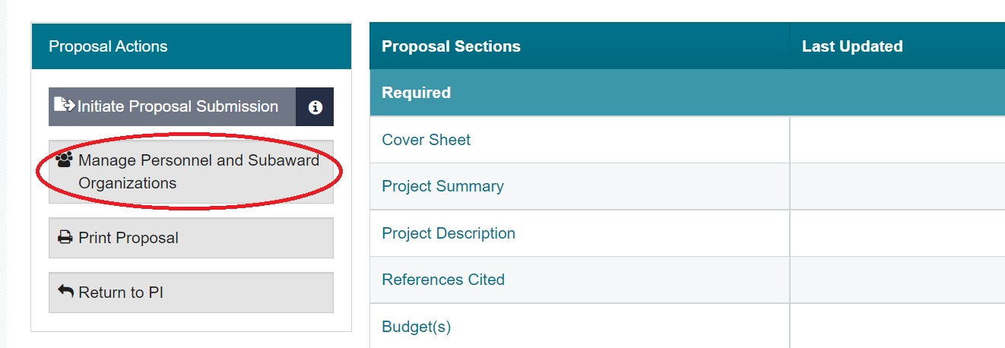

1. PI will need to click on “Manage Personnel” for the prime institution

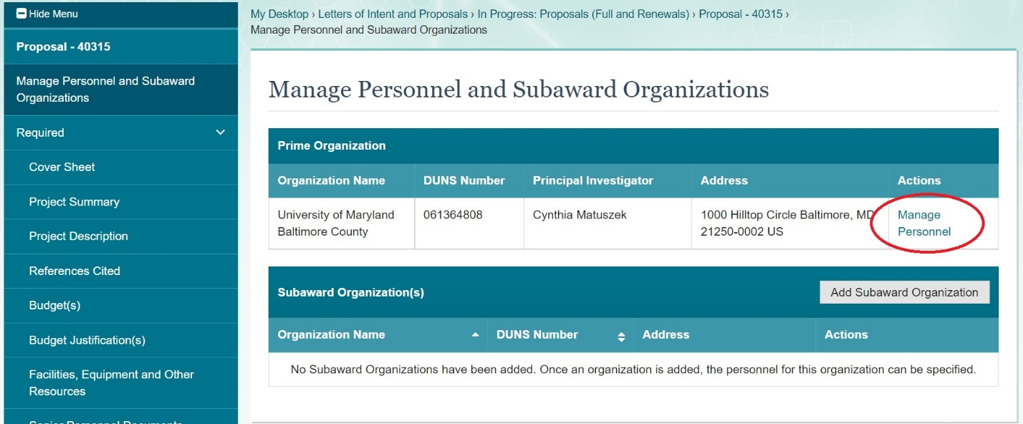

1. Using the Add Other Authorized User Button, enter the email or NSF ID of the staff to add them to the proposal

