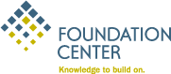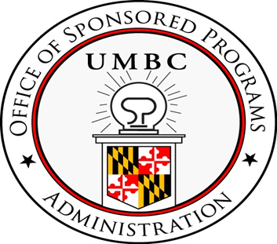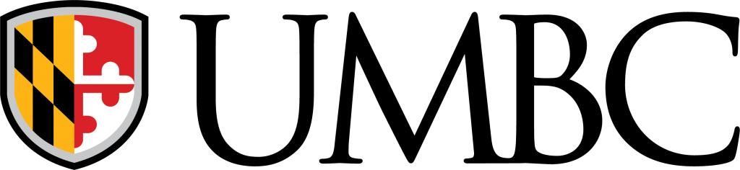
Getting To Know…

(PROFESSIONAL)

- What is Foundation Directory Online (FDO)?

Founded in 1956, Foundation Directory Online is an organization that allows subscribers to access comprehensive information on grant makers and their grants. FDO cites innumerable foundations across the United States-as well as other nations- that have and will provide grants for research organizations

  - FDO contains information on over 140,000 grantmakers (foundations, corporate giving programs, and grant making public charities in the U.S).
  - The database consists of over 4,000 sponsoring companies, offering a quick pathway to corporate funders;
  - The database contains over 11 million grants
  - FDO/ offers a keyword-searchable database which contain over 3 million recently filed IRS Forms 990 and 990-PF (filed by exempt organizations -- i.e., private foundations and private charities).
  - On February 1, 2019, FDO and GuideStar joined forces and became Candid. Both FDO and GuideStar work independently under the Candid “umbrella”.

- Advantages in Using Foundation Directory Online?

- Search across a funder's grants (using search criteria and indexes)
- Map a funder's grants
- Use Pathways to illustrate networks of funders and recipients
- FDO Quick Start
- User-friendly interface
- IPhone & Android Compatibility

In essence, FDO is a truly remarkable research tool. FDO offers the researcher a seemingly “endless” variety of possible sources of potential funding opportunities, from sources outside of the Federal Government realm of funding. Thus, it is a highly educational, functional, and user friendly database that warrants high utilization by those in the UMBC campus community.

Let’s Get Started…

III. How to Log In To Foundation Directory Online
Foundation Directory is a database that is available to faculty, staff, and graduate students who have a working, valid UMBC login name and password. Foundation Directory can be accessed on campus through the Office of Sponsored Programs’ website as well as off-campus through UMBC’s Global Protect VPN Portal. Instructions for using the Global Protect VPN can be found on the UMBC VPN Wiki link: https://wiki.umbc.edu/pages/viewpage.action?pageId=36766377
Instructions for FDO access are provided below.
On-Campus Access:
- FDO can be accessed through the OSP Website https://research.umbc.edu/office-of-sponsored-programs/.
- From the main OSP page, please use the Navigation pane on the left to click on “Proposal Information” and to then scroll down that page and click on “Funding Opportunities.” As an alternative, you can access the direct link to OSP’s “Funding Opportunities” Page as well: https://research.umbc.edu/external-funding-opportunities/
- Click on the hyperlink to Foundation Directory and the link (https://my.umbc.edu/go/143) will immediately direct you to FDO.

Off-Campus Access:
- Navigate to https://gpvpn.umbc.edu
- If you are not already authenticated, enter your myUMBC credentials and complete the two Factor authentication (i.e. DUO).
- Click "Browse without Client Software" and enter https://my.umbc.edu/go/143. Refer to screenshot below:

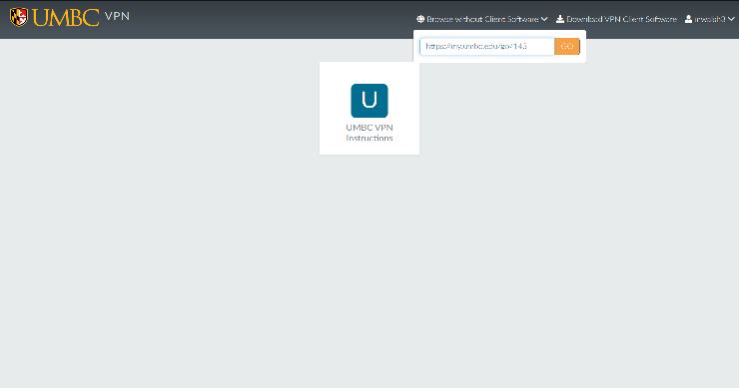

- You will arrive at the Home Page of FDO for UMBC. You will see that it says “Hi University Maryland Baltimore County” at the top of the screen (see screenshot below). Now you can begin to search for funding.

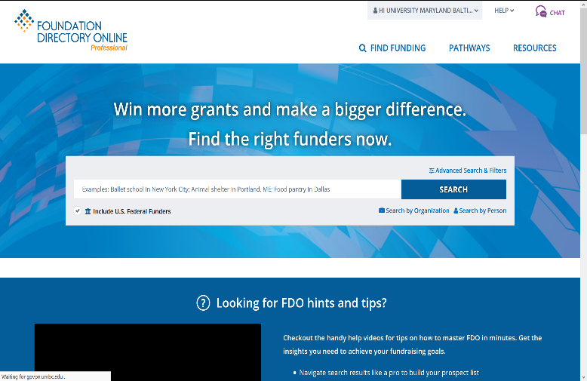

IV. How to Perform Searches:

Search Options (Basic and Advanced Options/Filters)

- Subject Area
- Geographic Focus
- Population Served
- Organization Name
- Location
- Who’s Who
- Transaction Type
- Support Strategy
- Organization Type
- Keyword
- EIN/BRIDGE Number
- Grant Amount
- Years

V. Contact and Assistance for Foundation Directory Online

FDO Support:
Foundation Directory Online features a comprehensive Help section for FAQs, FDO Guide, and Live Expert Chat. Simply click and “Help” at the top right of your screen and go to the appropriate section.

UMBC
Please feel free to contact UMBC’s Office of Sponsored Programs if you have questions about Foundation Online Directory and any other available databases that may offer potential funding opportunities. The UMBC FDO official contact is listed below.

UMBC FDO Contact
Dr. Michael Walsh
Grants & Contracts Manager/Training Coordinator
mwalsh3@umbc.edu
410-455-3037

UMBC Office of Sponsored Programs
ospa@umbc.edu
410-455-3140
www.umbc.edu/ospa

**References/Citations: Facts, figures, and other pertinent information regarding FDO were gathered from the following website http://fconline.foundationcenter.org/**

