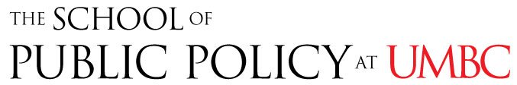

Information Session
Master’s Degree in Public Policy
Monday, April 25, 2016
12 – 1:00 pm, Public Policy 438
Lunch included

Learn about the UMBC Master’s in Public Policy (MPP), and the combined BA/MPP degree.
To register, send your name, year and major to Sally Helms (helms@umbc.edu).

