**POLI 409: Russian Politics**

Winter 2018

Dr. Grodsky

Isn’t it time to figure out what all this Russia stuff is all about?

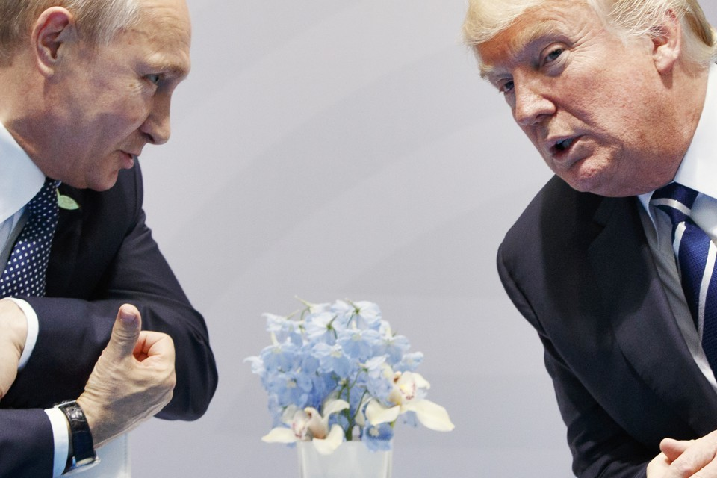

*If the 2016 election wasn’t enough reason, consider these:*

It is the **largest** in the world.

It has **more natural gas** than any other country on Earth.

It has one of the **greatest militaries** in the world.

It is a case study in the **failure of democratization**.

Its leaders view the **West as a great threat** to Russia’s 21st century revival.

Registration is open: This online course (including PowerPoint lectures) is limited to 20 students.