The race for the Arctic is on.

Here are three reasons you should care:

- Climate change is proceeding faster in the Arctic than anywhere on Earth. The Arctic is literally melting.

- The region is home to an estimated 90 billion barrels of oil, or 6% of all reserves, and the world's last new global trade route.

- Russia is staging an unprecedented military buildup in the region and the West is finally starting to respond.

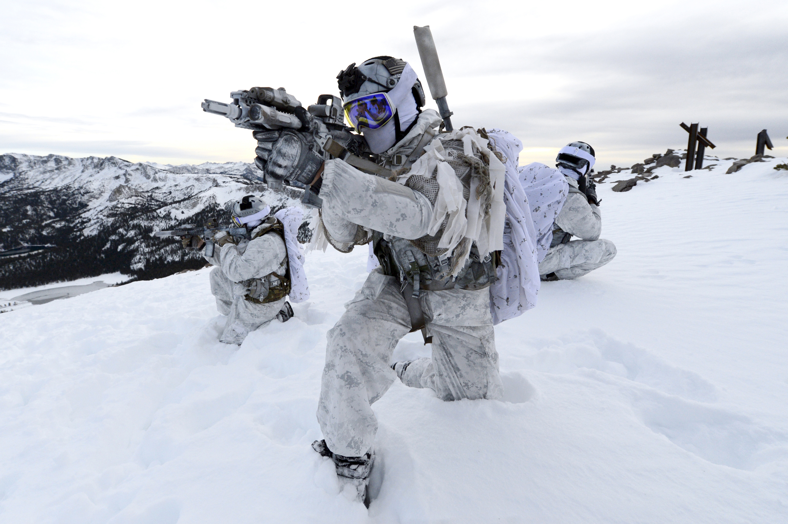

Want to learn more?

Arctic Geopolitics (POLI 409) – January 2020

Questions? bgrodsky@umbc.edu

