THE TUSKEGEE SYPHILIS EXPERIMENT: A TRAGEDY OF RACE AND PUBLIC HEALTH
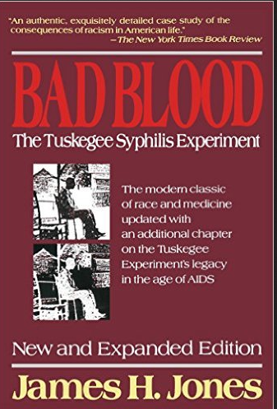
UMBC University Center Ballroom
Monday, March 27th 4-6 pm
Lecture & reception

Free and Open to the Public
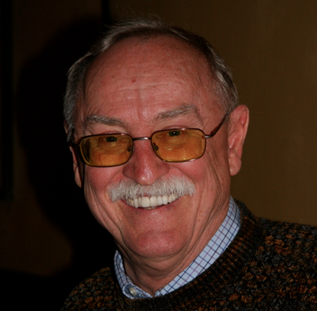
James H. Jones, PhD
Professor Emeritus
University of Arkansas
Historian
Author of Bad Blood: The Tuskegee Syphilis Experiment

UMBC Social Science Forum event co-sponsored by the
Departments of Sociology, Anthropology, and Health Administration and Policy (SAHAP),
History, and Biological Sciences
http://socsciforum.umbc.edu/

