is pleased to invite you to

**The Judith Shinogle Award Lecture**

**with Jennifer Walsh**

Thursday, November 1, 2018

4:00-6:00 p.m.

Albin O. Kuhn Library Gallery

Reception immediately following the lecture

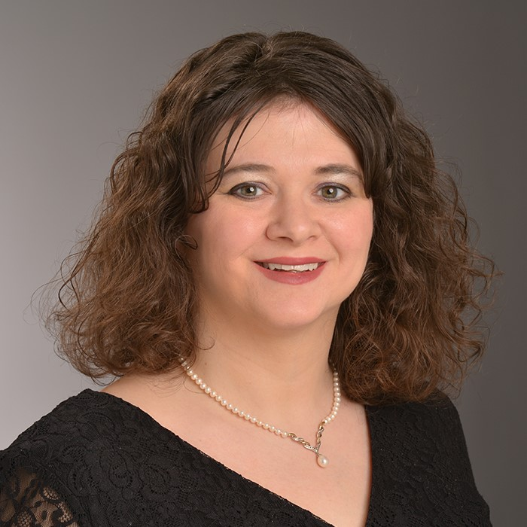Lecture: “**Is Saving Lives Enough to Reverse the Opioid Epidemic?”**

Bio: Ms. Walsh is a Ph.D. student in the School of Public Policy’s health policy track. She is currently a Disabilities Support Specialist at Towson University promoting equal access to educational opportunities to students with disabilities. Previously, she was a licensed Psychology Associate performing neurocognitive evaluations at Johns Hopkins Hospital Division of Medical Psychology. While working at JHH, she became interested in both the mismanagement and abuse of prescription drugs. Currently, she is focusing her studies on the opioid epidemic. Her dissertation topic is an examination of the effectiveness of Naloxone administration by a layperson on the overall mortality and recovery rate.  
  
Ms. Walsh received a M.S. in Clinical Psychology from Loyola University-Maryland and a B.S. in Psychology from Stevenson University. She is married to Michael Walsh, Ph.D., a graduate of UMBC's School of Public Policy and staff member in the Office of Sponsored Programs at UMBC. Together they have a three year old daughter named Elizabeth.