Dr. Curran’s Going Away Gathering
June 27th, 5:30-7:00PM

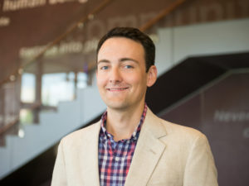

For the past four years, Dr. Chris Curran has been teaching and advising in the education policy and evaluation and analytic methods specializations. Students from all specializations have benefited from his expertise in the research methodology course. As many of you know, Dr. Curran and his family are departing UMBC this summer for a new adventure in Florida. He will join the faculty at the University of Florida’s College of Education as an Associate Professor of Educational Leadership and Policy. Before he leaves, we invite colleagues and students to join us for a sending off party in his honor. We will have drinks and light appetizers. We know Dr. Curran will enjoy seeing everyone once more before his move.
Where: Public Policy Building, 4th Floor
When: Thursday, June 27th, from 5:30-7:00PM
Who: Students, Faculty, and Staff. Families and kids are welcome as well.
Please RSVP to Sally Helms (helms@umbc.edu;
or Pam Doppler padoppler@umbc.edu)

