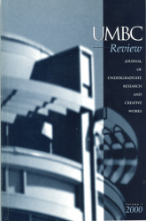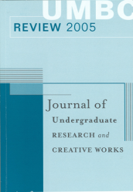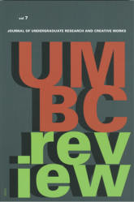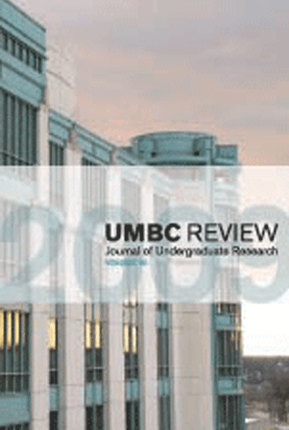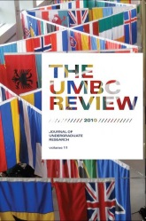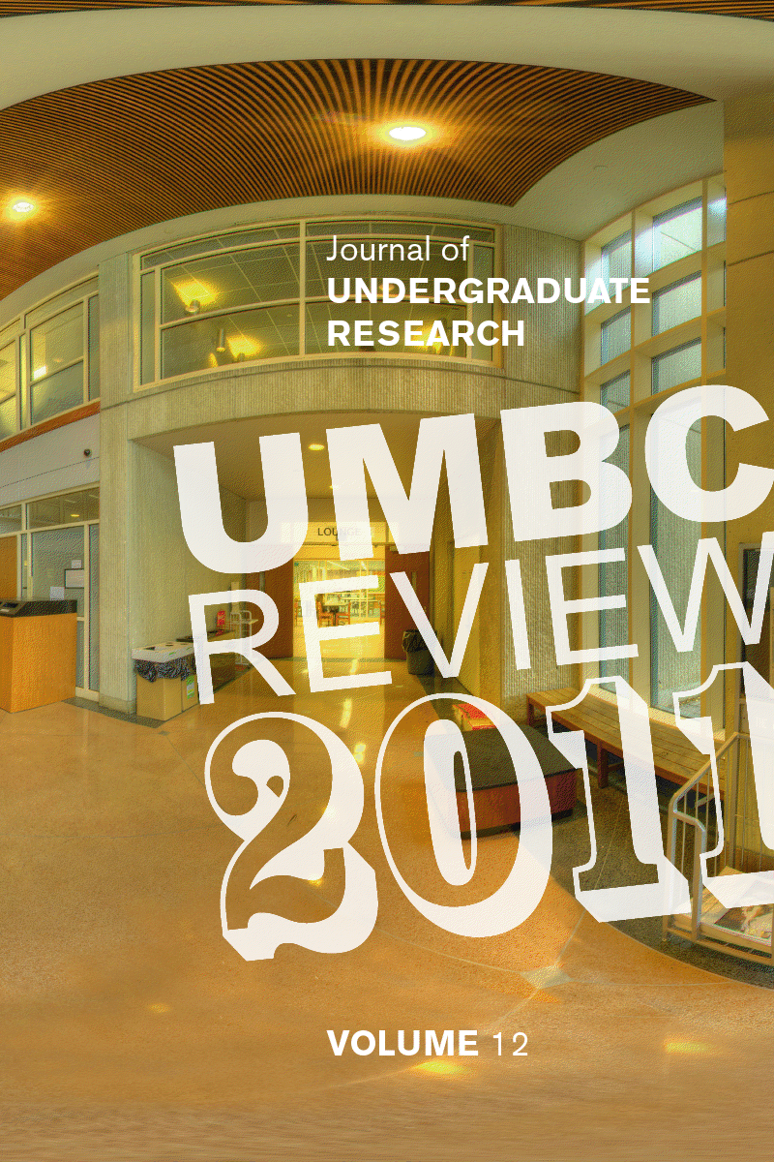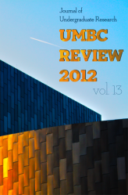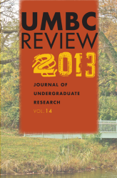
Research Paper Workshops
“How do I get my research published?”
Working in a lab this semester? Applying to an internship this summer?
Writing a research term paper for a course?

You might be able to publish your work for immortal recognition.
Hear the ins and outs of publishing from The UMBC Review editors.
We will teach you skills that are applicable for any research journal.

“How does the publishing process work?” “What is worthy of publication?”
“What does a formal research paper even look like?”

To find out, attend any of the following:
Noon 2/26 in MP008 OR 4pm 2/28 in MP008 OR 6pm 3/3 in MP102
Email us at umbcreview@umbc.edu with your questions.

