


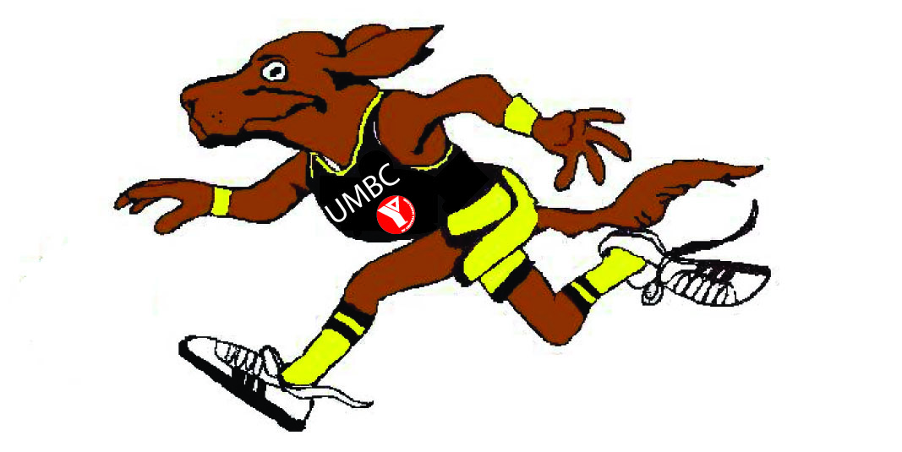
Brought to you by:
Entry Fee
$20
UMBC students and CCBC students pay $5.00
Race Day: $20

Register me for the: ____ 5K Run

Name:____________________________________ Address:_____________________________________
City/State/Zip:______________________________ Primary Phone: ( ) ________ - _________
Email: ________________________________ Gender (circle one) M F
Date of Birth (mm/dd/yy): __________ Age (on day of race):_______ T-SHIRT SIZE: _____

Payment Method

Total Amount: $______ Check______ Cash _____

Credit Card (circle) VS MC AMEX DISC Card #__ __ __ __ __ __ __ __ __ __ __ __ __ __ __ _

Exp. Date __ __ / __ __ Amount $_____________

Card Holder___________________________________

Signature ____________________________________

Please make checks payable to and mail to:
UMBC Athletics
1000 Hilltop Circle, RAC 331
Baltimore, MD 21250

Participant Waiver
I know that running is a potentially hazardous activity and I should not enter unless I am medically able and properly trained. I agree to abide by any decision of a race official relative to my ability to safely complete the run. I assume all risks associated with running in this event including, but not limited to: falls, contact with participants, the effects of weather including high heat and/or humidity, traffic and the conditions of the road, all such risks being known and appreciated by me. Having read this waiver knowing these facts, and in consideration of your accepting my entry, I, for myself and anyone entitled to act on my behalf, waive and release University of Maryland Baltimore County (UMBC) and all sponsors, their representatives and successors from all claims or liabilities of any kind arising out of my participation in this event. Furthermore, I grant permission to all the foregoing to use any photographs, motion pictures or any other record of this event for any legitimate purpose.

_________________________________ __________
Participant Signature Date

_________________________________ __________
Parent/Guardian (if participant is 18 & under) Date

Register on line at
www.ACTIVE.COM

Search: UMBC Dawg Chase
UMBC 5K Dawg Chase
Course Information
Runners will run through the UMBC Campus. One mile walk will be held at the UMBC Track Stadium. All runners will start at the UMBC Stadium. All runners will end the 5K race at Stadium Lot.

Saturday, October 16, 2010
Registration - 8:00am
Race Start - 9:00am
~
UMBC
Stadium Parking Lot
1000 Hilltop Cr.
Baltimore, MD 21250

