UMBC SGA Finance Board  Meeting Agenda  Thursday, August 22, 2019  6:30 pm, Skycroft Center | 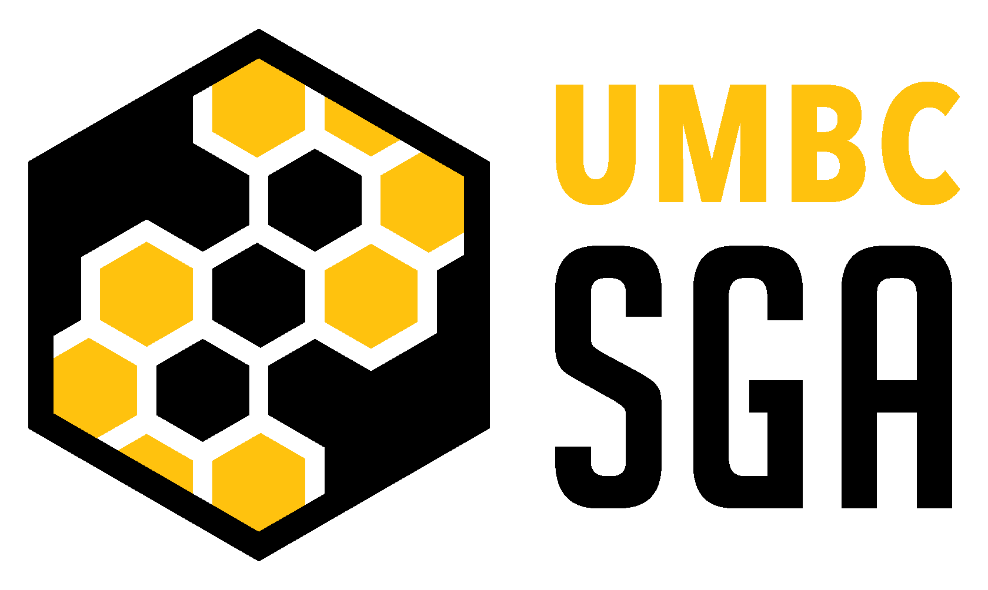
**All agenda times are tentative
- Call to Order 6:30 p.m.
  - Roll Call
  - Approval of the Agenda
- Caribbean Student Council 6:35 p.m.
- Musical Theater Club 6:45 p.m.
- Announcements 6:55 p.m.
- Adjournment 7:00 p.m.
  - Final Roll Call

