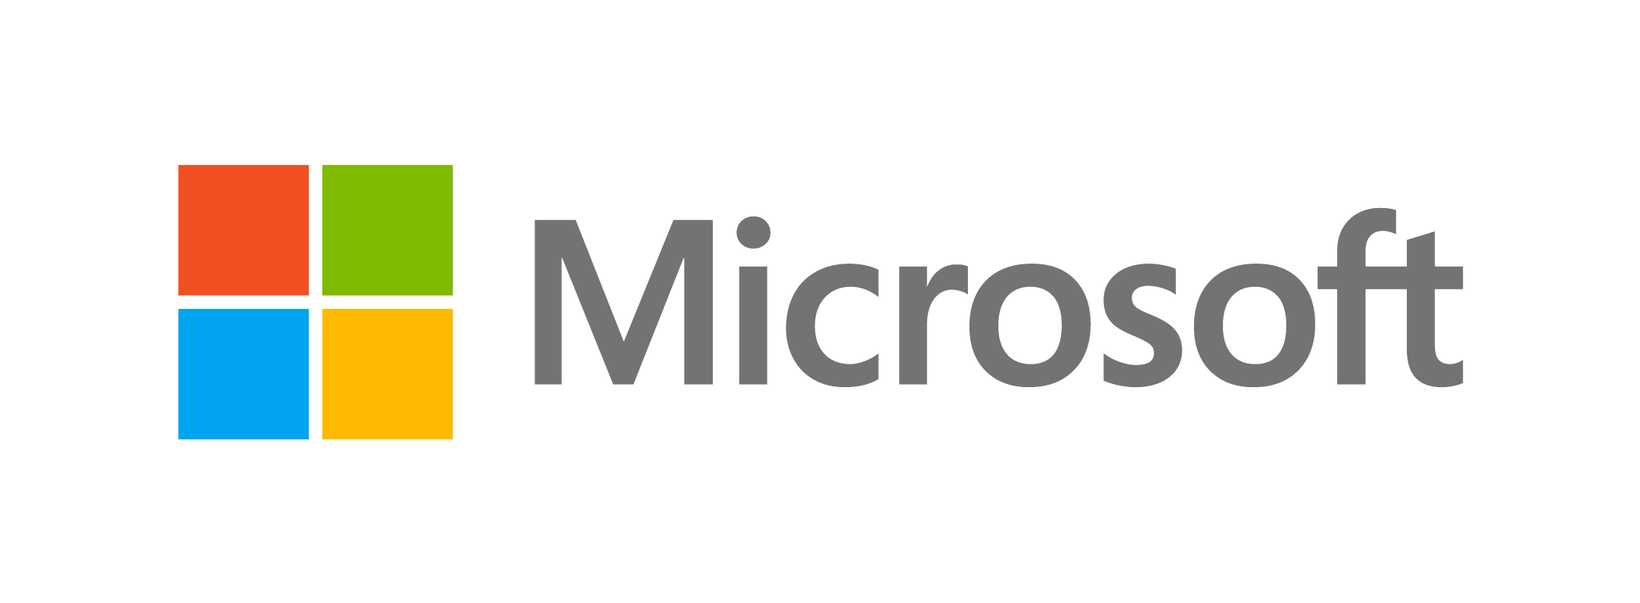
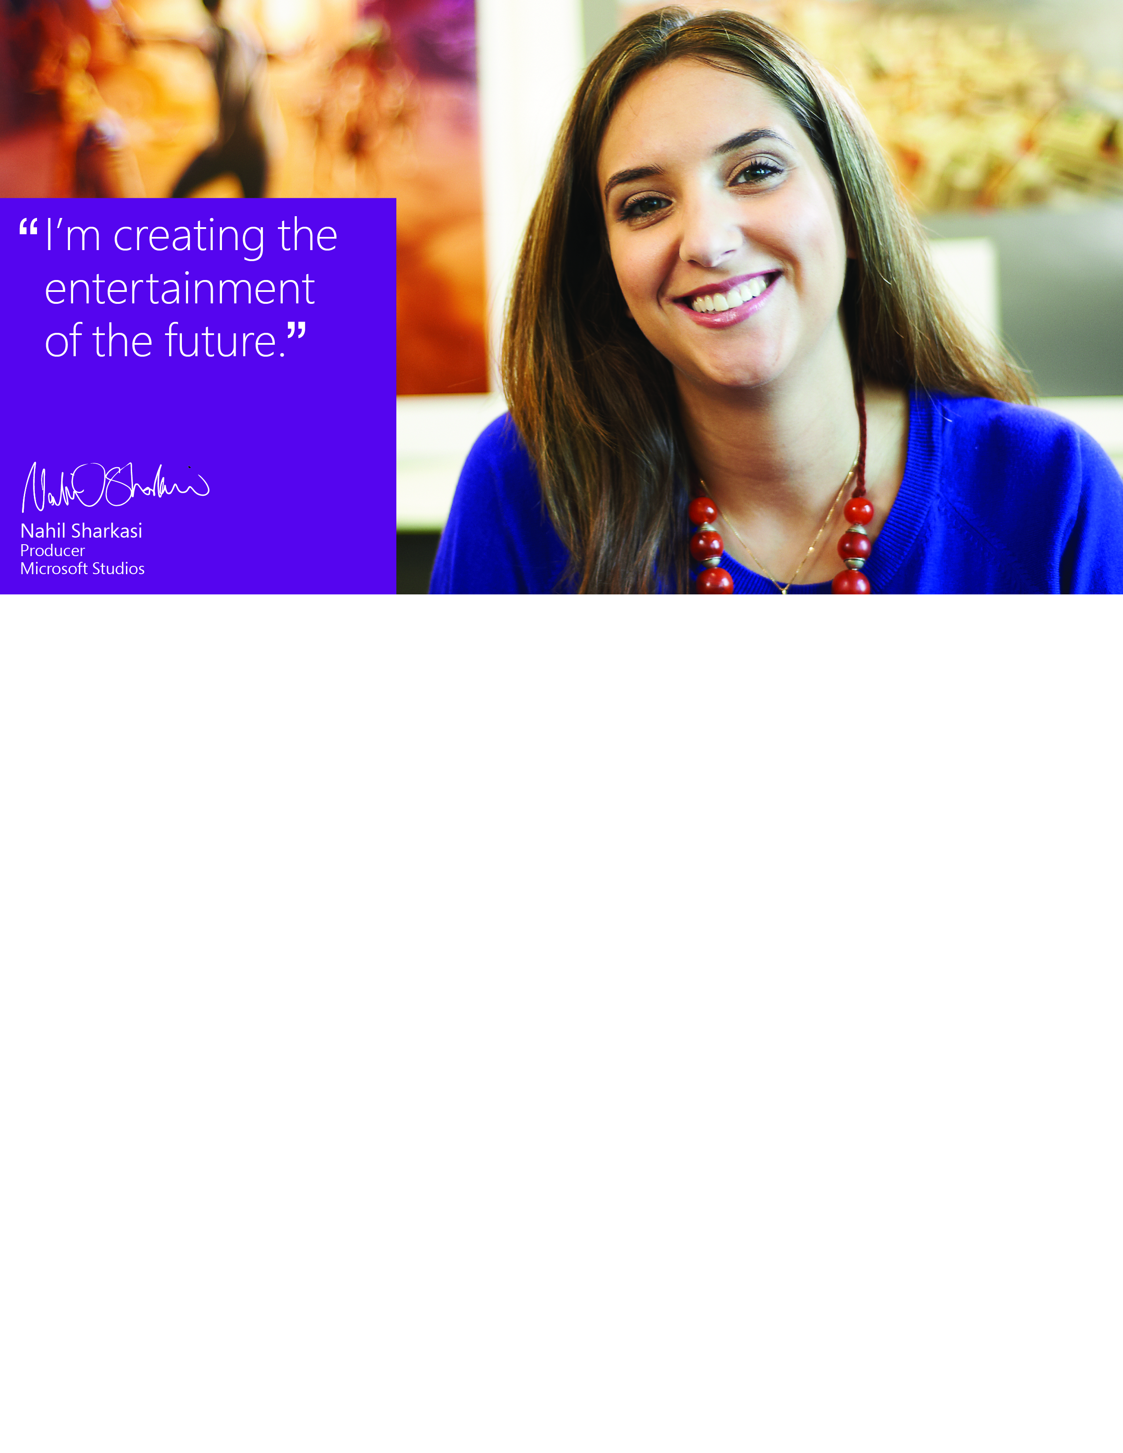
Meet the Company Presentation

Thursday, October 18th | 6:30PM | ITE 456

Bring your appetite for FREE food and a copy of your resume for a chance to win great prizes

Questions? Want to apply online? Check out our website at www.microsoft.com/university

What will you do?
microsoft.com/university/inventing

