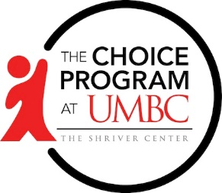
Job Developer

Job Description:
This position will work in the Choice Jobs Program, which provides job placement services to youth ages 14-24 years old in Baltimore City. The position will work out of the Choice Program’s Cherry Hill Office in South Baltimore and will directly serve young people in Baltimore City. The advisor will in essence act as job developer, finding possible job leads and connecting youth to opportunities. The applicant should have a strong passion for helping youth obtain their employment goals.

Qualifications:
- Works well in a team-oriented environment
- Confident in community employment networking
- Possesses current developed partnerships with employers
- Experience working with youth
- Problem solving and decision making skills
- Excellent written and verbal communication skills
- Proficient in Google Suite
- Able to navigate through Windows Operating and Point of Sales systems
- Valid Maryland state Drivers License
Job Duties/Responsibilities:
- Encourage, guide, and coach youth through a Racial Equity Lens
- Connect youth with employment opportunities based on their needs assessments
- Develop employer partnerships
- Host and attend job fairs
- Assist youth with acquiring documentation or certifications for job requirements
- Develop and oversee opportunities for youth to participate in other paid activities
- Once youth are hired, enter touchpoints into ETO (data tracking system)
- Other duties as assigned

*Telework required and nights and weekends required

Please contact Trenae’ Watson at trenae@umbc.edu with all inquiries or questions

