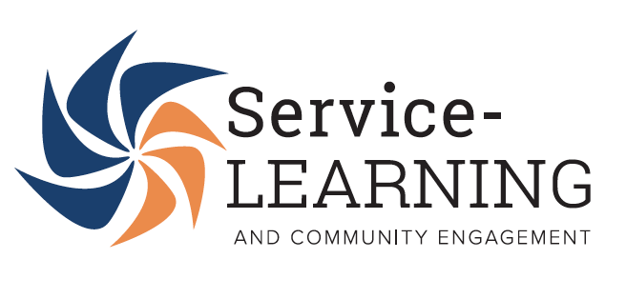

Service-Learning & Community Engagement Program Specialist

OVERVIEW
The Shriver Center is excited to offer this 3 month contractual position (with at least one opportunity to renew) to serve with the Service-Learning & Community Engagement (SLCE) team. As part of its mission to bridge campus and community to address critical social challenges, The Shriver Center has developed highly regarded and effective applied learning programs that meet the needs of numerous stakeholders: UMBC students, staff, faculty, and community partners. Partners include P-14 schools, non-profits, and government agencies. The SLCE team instructs the 096 Community Service & Learning Practicum as a strategy to strengthen UMBC’s community engagement capacity. SLCE staff secure, coordinate, and monitor approximately 800+ placements for UMBC undergraduate and graduate students each year. These experiences will deepen their personal, professional and academic development through teamwork, critical thinking, leadership, communication, and social responsibility.
RESPONSIBILITIES INCLUDE:
- Support SLCE staff to monitor Fall 096 Community Service & Learning Practicum placements
- Prepare for Winter 2023 and/or Spring 2023 placements
- Serve as thought partners in relationship development by utilizing the Shriver Center Partnership Guide: Values, Practices, and Principles https://shrivercenter.umbc.edu/partnership/
- Work with the SLCE team to develop and implement reflective activities (written, group)
- Promote opportunities and success stories through recruitment and retention efforts (presentations, Admissions events, student organization meetings, etc.)
- Engage in Shriver Living Learning Community programming
- Develop leaders through the Service-Learning & Community Engagement Interns and Coordinators (individual and large group) who manage large groups of service-learners

PREFERRED QUALIFICATIONS:
- Requires a Bachelor’s degree and one year of experience preferably in the non-profit/public sector, human resources, and/or higher education fields.
- Knowledge of service-learning/civic engagement/social justice work. Preferably has previous experience with the 096 Community Service & Learning Practicum
- Must have strong informal counseling and interpersonal skills; strong presentation, writing, computer, and organizational abilities
- Possess the ability to work effectively with diverse groups of internal and external contacts.
SALARY:
$25/HOUR, 20-30 Hours per week
This is a contractual position and is not benefits eligible

If interested, please submit your cover letter and resume to shrivercenter@umbc.edu

