UMBC
Office of Student Life
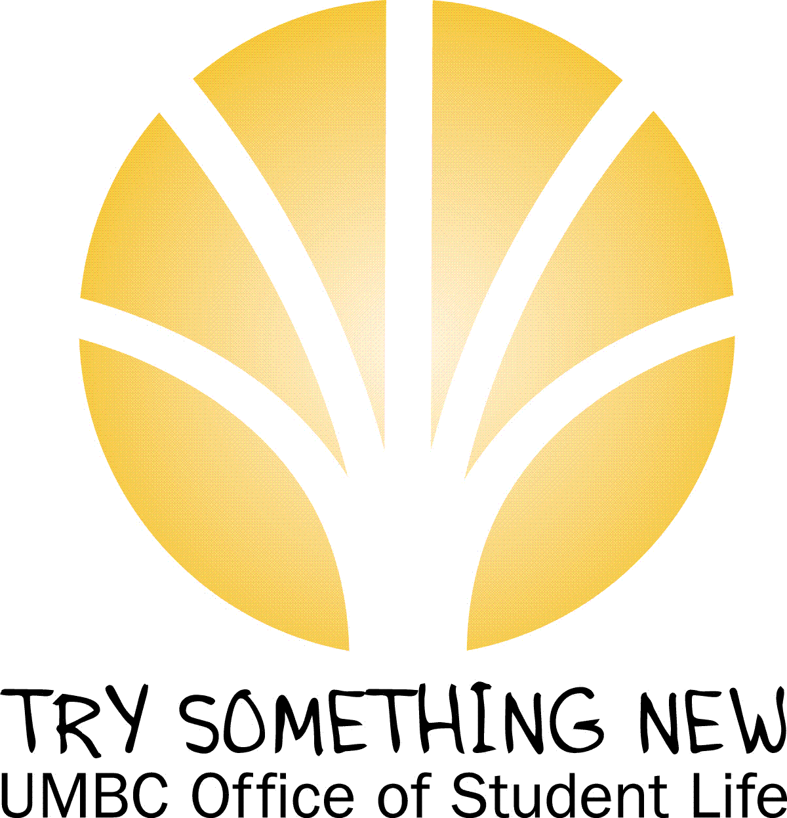

diversity educator InternS

Application Packet
~
application deadline:
Open until all positions filled; RECOMMENDED TO APPLY ASAP
~
Submit completed application to:
mosaic@umbc.edu or the office of student life – the commons, rm. 336

Questions? Contact lisa GRAY, assistant dir. for cultural and SPIRITUAL diversity; lISAMGRAY@umbc.edu; 410.455.8478

The UMBC Office of Student Life’s
Mosaic: Culture and Diversity center
Diversity Educator Interns

Description, qualifications and Application Requirements

Overview
The Office of Student Life’s Mosaic Center for Culture and Diversity is currently seeking student interns for the Fall semester. Diversity Educator Interns will facilitate students’ engagement in multicultural/diversity-related education, collaboration and community-building. Founded in 2004, the Mosaic has a proud history of student-visioning and vibrant programming. Interns are an integral part of the Mosaic’s future as a student-driven and campus community-centered space. Diversity Educator Intern positions are more than just jobs; they are unique opportunities to contribute to innovative, reflexive and social change-based education, respectful and civil dialogue, equitable and accessible resources, and inclusive evaluation processes within the UMBC community.

DESCRIPTION

What is the Diversity Educator Intern (DEI) Program?
The Diversity Educator Intern Program is a year-long leadership development program that trains UMBC students about multiculturalism, diversity, social justice and intercultural communication, and prepares them to be diversity educators and facilitators. Through the DEI Program, interns provide high quality diversity education dialogue and interactive learning opportunities for UMBC students. DEIs play an essential role in creating an inclusive and accepting campus community. The DEIs are supervised and coached by a staff member in the Office of Student Life.

What Do The DEIs Do?
DEIs design and facilitate interactive, diversity education workshops for campus groups, facilitate UMBC Talks diversity dialogues and other intercultural and/or cross-cultural discussions, and advise student leaders. Workshops may be requested by organizations, classes, and offices. Sometimes the goal is just to help the group to understand and learn with one another better. Other times, groups are experiencing intra/intercultural communication problems and want DEIs to help them figure out ways they can overcome those difficulties. The DEI role is not to solve problems, but to help groups solve their own problems and to help develop diversity and multicultural awareness, knowledge and skills through fun, safe and interactive activities.

What are the Benefits of Being a DEI?
- Acquire practical experience designing, facilitating and implementing creative diversity workshops and dialogues
- Receive professional diversity education advising and excellent training
- Become more involved with the university community and help your fellow students learn about multiculturalism, diversity, and social justice
- Potential to receive service learning leadership, internship or transcript notation from the Shriver Center
- Potential to receive 1-3 academic credits via Shriver Center depending on your major
- Build your resume- employers and graduate schools often look for knowledge of and demonstrated experience working with diverse populations
- Be part of a fun, positive team!
QUALIFICATIONS

- Must be committed to being a peer role model and making a positive impact on the UMBC community;
- Must exhibit good written & verbal communication skills;
- Must have proactive work habits;
- Must be able to able to identify some ways diversity enriches the UMBC community;
- Must have a demonstrated commitment to building mutual understanding, respect, and civility among all people;
- Must be willing to become, if not already, well-connected to students, faculty, staff and other campus resources;
- Must be able to work with people from all backgrounds and members of all social identity, cultural, ethnic, faith-based and service/social action groups;
- Must have and maintain a minimum cumulative GPA of 2.5;
- Must be willing to work for the entire semester for at least 5 hours/week;
- Must be able to attend the following events and meetings during the course of the semester: Diversity Educator Intern Orientation and Training (prior to the start of the Fall semester), Training and Leadership Development Meetings (frequency TBD), Welcome Week “RESPECT” program and diversity receptions, Fall Involvement Fest (exact date, TBA); and
- Must be a full-time, matriculating student at UMBC.

COMPENSATION/HOURS

Diversity Educator Interns will receive academic internship and/or work-study pay for time worked and pending satisfactory work evaluations. You must be willing to work for the entire semester for at least 5 hours/week.

APPLICATION DEADLINE AND SUBMISSION REQUIREMENTS

Applications for the Fall 2012 semester will be accepted as of May 21, 2012. They can be requested via email (mosaic@umbc.edu) or picked up at the front desk of the Office of Student Life (Commons, Suite 336) from Mon.-Fri., 8:30am-5pm. Please Note: Only complete applications will be considered for an interview. Upon successful receipt and review of completed applications, candidate interviews will be scheduled via email or phone on a rolling basis. The interview and selection process will continue until all positions are filled. Interested students are encouraged to apply as soon as possible. Questions? Contact Lisa M. Gray at 410-455-8478 or lisamgray@umbc.edu.

OSL MOSAIC CENTER

DIVERSITY EDUCATOR INTERN APPLICATION

Contact Information

Full Name_________________________________________________________________________________

E-mail Address_____________________________________________________________________________

Summer Address____________________________________________________________________________

Academic Year (2012-2013) Address___________________________________________________________________________________

Best Contact Phone Number___________________________________________________________________

DEMOGRAPHIC Information

Current Class Standing (Circle): Freshman Sophomore Junior Senior Graduate Student

Major/Program_____________________________ Completed Hours____________________________

Credit Hours this/upcoming semester ______ ___ Cumulative G.P.A.___________________________

Please list activities and obligations during the school year: (internships, employment, student orgs, community activities, etc.)
______________________________________________________________________________________________________________________________________________________________________________________________________________________________________________________________________________________________________________________________________________________________________________________________________________________________________________________________________________________________________________________________________________________________________________________________________________________________________________________
________________________________________________________________________________________________________________________________________________________________________________________________________________________________________________________________________________________________________________________________________________________________________

Work Related and/or Character References (Required; Non-Family members only)

Name____________________________________________________________________________________
Relationship___________________________________________________________ ____________________
Best Contact Phone Num._____________________________________________________________________

Name____________________________________________________________________________________
Relationship___________________________________________________________ ____________________
Best Contact Phone Num._____________________________________________________________________

Please include the following with your completed application

Please type your answers to the following on a separate sheet of paper (please think through your answers and include details where possible- limit to two pages only). Feel free to attach a resume as well (not required).

- Why are you interested in becoming a DEI?

- What cultural and/or social identities (ex., regional/natl. origin, race, ethnicity, gender identity, sexual orientation, socioeconomic/class background, religious or spiritual background, political affiliation, generational group, etc.) do you connect to the most? Why?

- In your own words, define, compare and contrast multiculturalism, diversity, and social justice.

- Please discuss past experiences with diverse populations (be specific) at UMBC and/or prior to your time at UMBC. What did you learn from these experiences?

- What role should the DEIs play in creating an inclusive community at UMBC?

- Is there anything else about yourself you would like to tell us?

An interview is required; please circle the times that will work best for you.
Mondays 10-11am 11am-12pm 2-3pm
Tuesdays 10-11am 11am-12pm 2-3pm
Wednesdays 10-11am 2-3pm 3-4pm
Thursdays 10-11am 11am-12pm 2-3pm
Fridays 10-11am 11am-12pm 2-3pm

Acknowledgement

I have read and understand the qualifications required for becoming a Diversity Educator Intern. I further understand the Office of Student Life reserves the right to review my academic and judicial records at UMBC in order to ensure that I am in good academic standing.

________ _______
Signature Date

Please submit to: The Office of Student Life - The Commons, Rm. 336 or mosaic@umbc.edu

