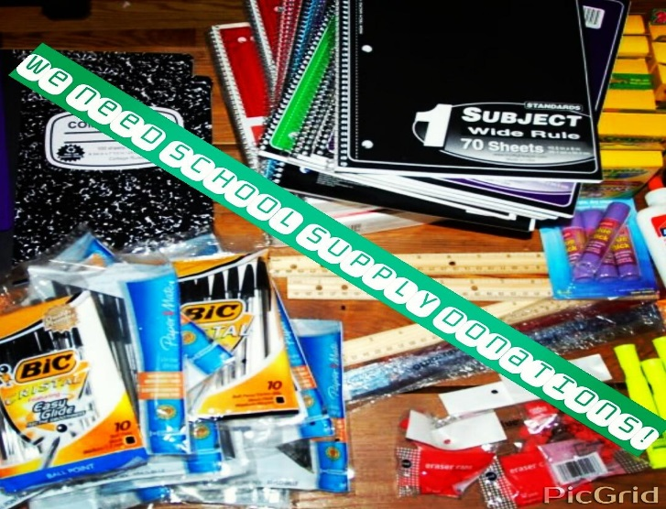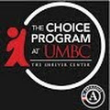
The Choice Program is in need of school supplies donations to be distributed at our Jam & Slam event on August 16th, 2016 to our program youth and the Cherry Hill Community. Please drop off donations at the Shriver Center.
Items Needed (not limited to):
Lined paper
Spiral notebooks
Back packs - biggest need!
Index cards
Pencils
Pens
Pencil case
Highlighters
Pocket folders
Glue
Scissors

