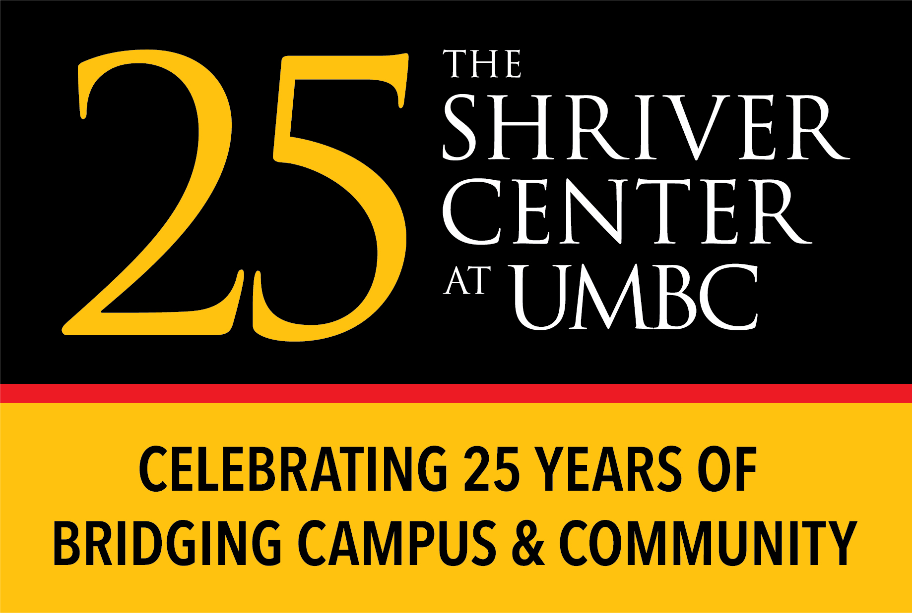
2018-2019 Sherman Center/Shriver Center Literacy Fellow Application

The multidisciplinary Sherman Center for Early Learning in Urban Communities (Sherman Center) was established to advance George and Betsy Sherman’s vision of improving learning experiences and outcomes for young children in Baltimore City. To achieve this mission, the Sherman Center connects theory, research, and practice, and schools, families, and communities to promote the educational success of children ages three through eight.
The Sherman Center began working with early childhood educators at two partner schools in the 2017-18 school year. These schools, Lakeland and Maree G. Farring, serve students in grades preK-8. In the 2018-19 school year, the Sherman Center will expand its work to two additional partner schools: Curtis Bay and Bay Brook.
The Sherman Center collaborates with its partner schools to implement site-specific and cross-site projects to improve early literacy instruction, resources, supports, and outcomes. Its focus on early literacy reflects the schools’ goals and a growing recognition of the importance of early literacy for young children’s lifelong success. The mission of The Shriver Center is to address critical social challenges by bridging campus and community through engaged scholarship and applied learning. To achieve these complementary goals, the Sherman Center and the Shriver Center seek energetic, organized, and dependable student leaders who love children and learning to serve as Sherman Center Literacy Fellows.
Each Sherman Center Literacy Fellow will enroll in The Shriver Center’s 096 Community Service & Learning Practicum (Leadership Section) and organize literacy tutors (also enrolled in the 096 Community Service & Learning Practicum ) at one of the Sherman Center partner schools as a Student Coordinator.
Fellowship Hours – A minimum of 4 hours (8 a.m. - 2 p.m.) and two days/week (Monday-Friday). The hours and days must be set and arranged with the school liaison at the beginning of each semester. Please account for the time it takes to get to and from the schools. From UMBC, depending on the time of day, it could be between 15-20 minutes.
Fellowship Stipend - $750/semester
Fellowship Responsibilities* include, but are not limited to the following:
  - Support young children’s (grades preK-3) literacy development as guided by the assigned classroom teacher during scheduled hours and days;
  - Recruit one to three additional UMBC literacy tutors to assist students in other assigned classrooms;
  - Monitor, support, and evaluate the attendance and performance of UMBC literacy tutors;
  - Meet at least monthly with school liaison and classroom teachers to establish goals, evaluate the performance of literacy tutors, and plan for future activities;
  - Meet monthly with Sherman Center Director to report on progress, challenges, and future activities;
  - Participate in professional development on young children’s literacy development provided by the Sherman Center or its affiliates;
  - Participate in bi-weekly Shriver Center Student Coordinator meetings;
  - Submit semi-annual (December) and annual (May) reports documenting tutoring goals, hours and activities, outcomes, and challenges to Sherman Center Director and campus advisory committee.
*Fellows will be responsible for their transportation to and from the partner school sites. Therefore, preference will be given to applicants with a valid driver’s license and insurance. Pending availability, Fellows may utilize one of The Shriver Center vehicles to transport other literacy tutors to and from the site.

Please complete the following application and return it to Sherman Center Director, Professor Mavis Sanders, via email at msanders@umbc.edu by Sunday, July 22, 2018.
Interviews will be conducted between Monday, July 30 - Wednesday, August 1, 2018.
Selected fellows will be notified by Monday, August 6, and offer responses will be required by Friday, August 10, 2018.

Full Name: Academic Standing (Year):

Cell Phone Number: Email Address:

What is the best way to get in touch with you?
Please indicate your availability for a 45-minute interview between Monday, July 30 and Wednesday, August 1 by listing ALL days and times you are available between 10 am - 4 pm.

ACADEMIC INFORMATION
Undergraduate Major: Declared Minor, if applicable: Cumulative GPA:

Expected date of graduation:

Have you taken any education or child development courses?
(check appropriate box) ☐Yes ☐No
If yes please list:

Have you participated in any leadership development/training courses, workshops, seminars, conferences etc.?
(check appropriate box) ☐Yes ☐No
If yes please list:

SHORT ANSWER QUESTIONS
Please answer the following questions briefly AND in a way that allows us to get to know you, your aspirations, and your motivations.
- What motivated you to apply for this position?

- Describe your future goals. How would this experience support those goals?

