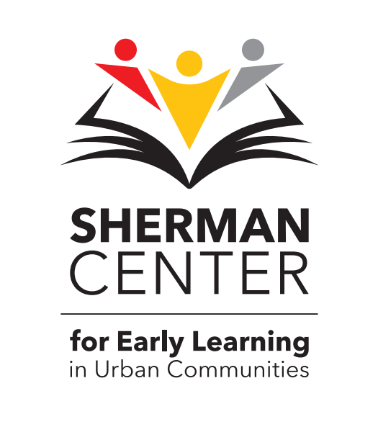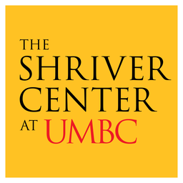
The Sherman Center/Shriver Center Literacy Fellows Program

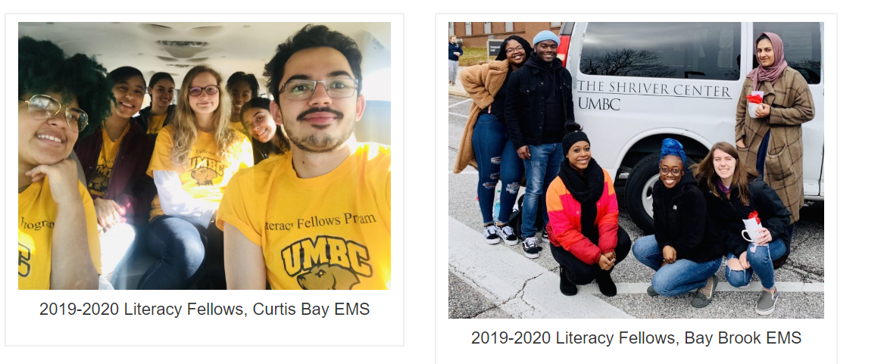
Join the TEAM! (Transportation Provided*)

Bay Brook EMS – Monday & Wednesday, 9:30-11:45 a.m.
Curtis Bay EMS – Tuesday & Thursday, 8:00-10:30 a.m.

Literacy Volunteers support 1st and 2nd grade teachers by:
  - Assisting with small group literacy activities
  - Preparing literacy materials for classroom instruction
  - Helping students with writing assignments
  - Reading with students
  - Serving as mentors and role models for young learners

For more information, please contact Nihira Mugamba (Bay Brook) - mnih1@umbc.edu or Ajay Kharkar (Curtis Bay) - ajk1@umbc.edu

