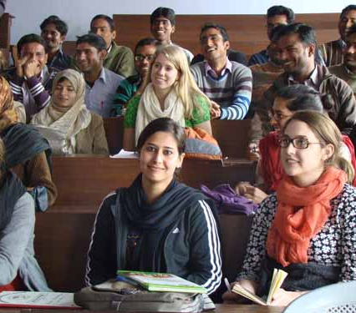







UMBC

Social Work

Field Fair
13thth
Join social work students who are currently doing their field placement for a Q&A. Find out more about how the field placement works, what is expected of you, and network with other social work students.
7th Floor of the Library
11am – 1pm, November 13th
Questions: Qureshi3@umbc.edu

Nov
Type to enter text

