STATA SEMINAR!
THE INFO:
PURPOSE: To inform interested students about STATA. STATA, a statistical analysis software, is becoming increasingly in demand for those seeking careers in various social science fields
FEATURING: Dave Marcotte
DATE: April 28th, 2015
TIME: 6 – 7:30 PM
LOCATION: The Community Center Multipurpose Room (Between Terrace and West Hill)
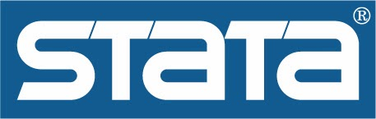
Sponsored By:
The Sociology Graduate Student Organization and Public Policy Graduate Student Organization

