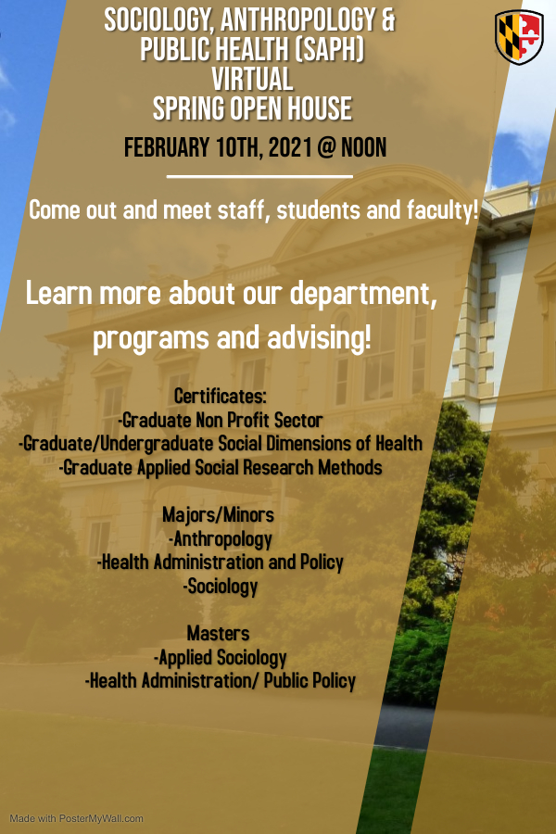

**Webex Link** - SAPH Virtual Open House

**Questions? Please contact** [**shodges1@umbc.edu**](mailto:shodges1@umbc.edu)