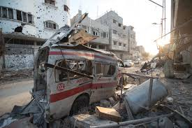

# What’s HAPPening this Summer!

MoWe 6:00PM - 9:10PM

Math & Psychology 010

7/6/2015 - 8/14/2015  
Summer Six Week – Second Session

## INSTRUCTOR-

## Charles Cange



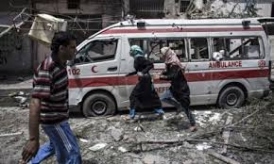

**SUMMER COURSE!**

**HAPP 398 – Health, Environment and Armed Conflict**

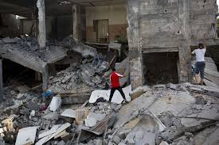

This class explores the interrelationship between health, the natural environment and armed conflict. Using specific case studies, this course will explore the connections between environment, health, security, conflict, poverty and peacemaking.

The course will focus on the following dimensions: 1) The impact of environmental degradation and energy source depletion on conflict formation

2) Conflicts arising out of a context of contested resource wealth

3) Environmental impacts of armed conflicts and the war system

4) Opportunities for environmental peacemaking based on a recognition of shared interests and vulnerabilities.

**UMBC**

Health Administration &

Policy Program