SUMMER 2016
ANTH 211: CULTURAL ANTHROPOLOGY
GEP "Culture" OR "Social Science" (3 credits)
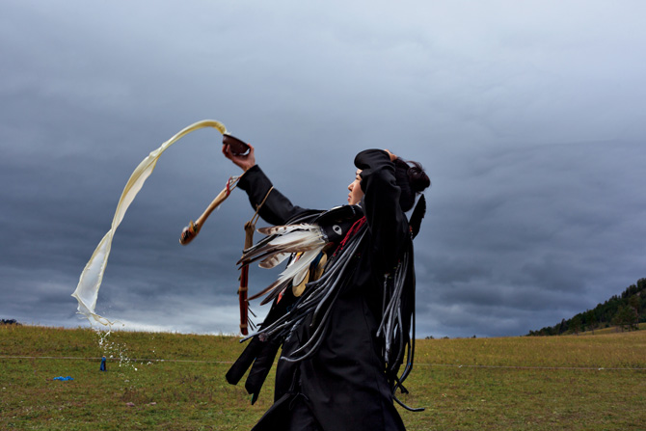

Anthropology is both a theoretical and applied field involving the study of humanity in its socio-cultural dimensions. The goal of this course is to provide a broad perspective of human life through cross-cultural comparisons of topics such as language, race and ethnicity, economics, gender, politics, ritual, art, and religion. Students will learn how anthropological theories and methods developed over time, research skills, and how to present ideas effectively as a speaker and writer in a social science format.
The course introduces students to the concepts, approaches, and skills of a particular discipline - Cultural Anthropology concerned with intercultural studies. The class will examine various anthropological approaches to understanding human behavior, and highlights insights to other cultures as well to our own culture.

SUMMER SESSION I: SUMMER SESSION II:
May 31 – July 7, 2016 July 12 – August 18, 2016
Tuesday/Thursday 1-4pm Tuesday/Thursday 6-9:10pm
Instructor: Jana Rehak, PhD Instructor: Bambi Chapin, PhD

