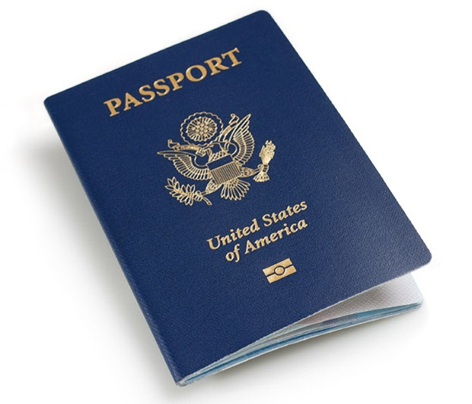
Need A Passport ?
Come to UMBC's Passport Day!
October 19th 11am-3pm

Commons 329

You will need to bring the following with you to apply for a new U.S.
passport:

- Proof of U.S. citizenship: Must be an original - Example: a certified birth certificate; Certificate of Naturalization; Certificate of Citizenship; Report of Birth Abroad
- Proof and photocopy of Identity
- 1 color passport photograph - two-inches square, taken within the last six
months, sharp focus with a white background. Passport Photos may be
taken at Commonvision for $5.30 .
- A completed, but UNSIGNED passport application form DS-11 in black ink
- Payment - Please see below for information about fees and payment
options.
- Please bring evidence in support of a name change, if applicable.

Note: If you have a previously issued US Passport Book or US Passport card,
please bring it with you.

Fees: to be paid by personal check or money order ONLY
- U.S. passport: $110 (payable to U.S. Department of State)
- $25 execution fee (payable to the Baltimore County Public Library)
- $60 expedited fee (payable to U.S. Department of State)

The Baltimore County Public Library’s returned check fee is $25. ALL FEES ARE NON-REFUNDABLE.
Current processing times for US passports are as follows:
Routine: 4-6 weeks
Expedited: 2-3 weeks (+ $60 fee)
If you are interested in renewing your U.S. passport, you can come to Passport Day to have official passport photos taken and pick up a DS-82 but you will mail in these documents yourself.
For additional information about applying for a new US passport, including special requirements for applicants under the age of 18, please visit http://travel.state.gov

