UMBC Guide to Chinese Language Study in Taiwan

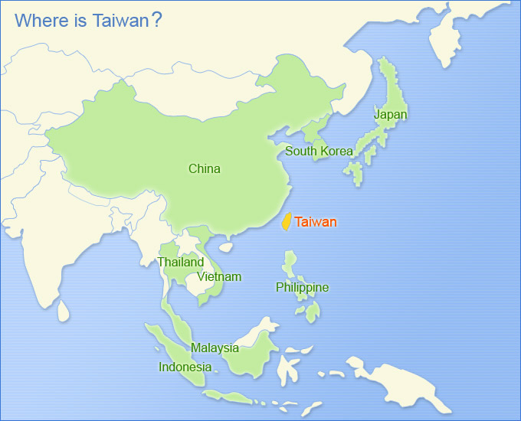

PART I. CHINESE LANGUAGE CENTERS

A. List of Chinese Language Centers, Ministry of Education, Republic of China: http://english.moe.gov.tw/ct.asp?xItem=9693&CtNode=417&mp=1

B. List of Recommended Language Centers and Accompanying Commentary by Dr. Meredith Oyen, History

1. National Taiwan University (NTU) 國立台灣大學 （台大）
Centrally located at Gongguan MRT stop; this is the best university in Taiwan. There are two options for study at NTU:
- ICLP (Int’l Chinese Language Program): This is the old Stanford IUP program, which moved to Beijing in the 1990s and was renamed the ICLP in Taiwan. It’s an intensive program – unlike all the others, you could not do something else at the same time as you completed this program. Has its own curriculum. Tuition rates are also much higher. Small classes – 3 or 4 students per class, and you take separate hour-long electives in reading, speaking, composition, etc. Also teaches classical Chinese. Traditionally only for more advanced students, but they’ve added a beginner’s section.

- Chinese Language Division Language Center: http://cld.liberal.ntu.edu.tw/en/language.htm
This is NTU’s answer to the NTNU/Wenhua Chinese programs, and it follows their model. Classes meet for just under three hours, and are set at beginning, intermediate, and advanced. Uses the curriculum shared by most of the language centers in Taipei.

2. National Taiwan Normal University (NTNU) 國立台灣師範大學 （師大）
- Mandarin Training Center: http://www.ntnu.edu.tw/oia/multi/english/mtc.html, http://140.122.110.12/mtcweb/index.php?visitor=future-student&lang=en
One of the flagship programs for foreign students; they developed most of the curriculum used around the island (including the Practical Audio-Visual Chinese series of books). It’s centrally located near the Taipower Building MRT stop on Hoping (Heping) Road. Up to ten students per class, and regular courses meet 15 hours a week. but the size of the program means they can offer cultural supplements (calligraphy classes, etc.) The most common place for foreign students to go, so the program is huge.

3. National Chengchi Univerity (NCCU) 國立政治大學 （政大）
- Chinese Language Center: http://mandarin.nccu.edu.tw/english/about.php
follows the format of NTNU and uses the same books, but committed to smaller class size (caps classes at 7, but often they run a little smaller). The university is at the base of Zhinan Mountain in southwest Taipei; you get there by going to the end of the Mucha line and taking a short ride on a bus, though you can also take bus 236 from anywhere downtown and end up in Mucha. They also offer many supplemental classes, activities, and fieldtrips.

4. Chinese Culture University (CCU) 中國文化大學 （文大）
- Mandarin Learning Center: http://www.pccu.edu.tw/intl/index-e.htm
Same format and books as the previous two. 6-10 students per class, though they have some higher-priced smaller classes available. As a sign of the times, they now offer a full program in simplified characters and HSK test training – not something offered elsewhere, as far as I know. When I lived in Taiwan, this was the school of choice for Korean students, though I’m not sure why!” The main campus is up in the mountains near Tianmu (it’s actually very pretty), but the Mandarain center is more central, located near the Technology building station and the east side of Daan Park.

5. Taipei Language Institute (TLI) 中華語文研習所
- I’m almost certain this place would not be included with government-sponsored scholarships, but students should know that it exists. It has the standard 15 hours a week with the NTNU textbook option, but it also has many supplementary courses for specific purposes, like oral Chinese for business. You can also sign up for one-on-one tutorials in which you pick the number of hours and shape the curriculum (useful if you’re slogging through a certain kind of research while in Taipei). They have branches all over Taiwan (and, in fact, China), but the main office is on Roosevelt Road, just north of NTU. They have one of the better Taiwanese language programs.

I recommend NCCU the most – not just because I went there, but because I had friends from all the other language centers at the time (several of whom ended up transferring!). All the Mandarin training centers offer the same basic course – 15 hours/week using the NTNU book series – but the NCCU program promises the smallest class sizes, largely because it is not as centrally located, so it has to work a little harder to get and keep students.

C. List of Recommendations made by Hilda Huang (TA in MLLI)

In Taipei City, convenient transportation but the living cost will be higher:

1) National Taiwan Normal University [#2 on Dr. Oyen’s list]
http://web.mtc.ntnu.edu.tw/mtcweb/index.php?visitor=future-student&lang=en

2) ICLP (National Taiwan University) [#1 on Dr. Oyen’s list]
http://iclp.ntu.edu.tw/

3) National Chengchi University [also #3 on Dr. Oyen’s list]
http://mandarin.nccu.edu.tw/english/index.php

Outside Taipei City, less convenient transportation but the living
cost will be lower:

4) Tunghai University
http://www2.thu.edu.tw/~clc/eng/about.htm

5) National Cheng Kung University
http://kclc.ncku.edu.tw/langcenter/eindex1.php

Please note: Many of these language centers also maintain Facebook pages. You should spend some time online researching your top choices to get a better sense of them.

This packet and the accompanying application materials were compiled by Dr. Constantine Vaporis (Director, Asian Studies Program), together with, Ms. Hilda Huang (MLLI), Dr. Gene Schaffer (Chair, Department of Education), and Dr. Meredith Oyen (History). Dr. Souders and the Study-Abroad Office will assist you with the mechanics of the study abroad process.

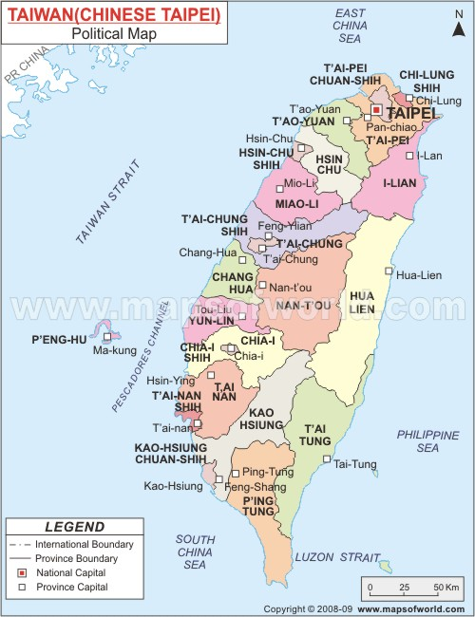
PART II. ESTIMATED FINANCES

Sample Estimated Budget for Summer Language Study
1. COSTS:
A. Round-trip economy airfare (2 or more stops) $1,600.00

B. Tuition and other fees for 2 months at NTNU: $2,174.90 1. @ NTNU (Nat’l Taiwan Normal Univ.) $1,358
Intensive (15 hrs./wk.): NT (New Taiwan Dollars): 21,600 ($711.45)
Student fees: 1,000 NT ($33)
Health insurance: 680 NT/mo. x 2 = ($45.45)
Textbooks: NT 800 NT ($27)
Optional: culture class @ 4,500 NT ($150)

2. @ NTU (Nat’l Taiwan University) $3,550

C. Accommodation for 2 mos. (varies widely depending on type: $650

D. Food/Daily Expenses: $250/mo. x 2: $500

Total estimated costs at National Taiwan Normal University: $4,874.00
Total estimated costs at National Taiwan University $6,300.00

2. SCHOLARSHIPS: $2,666,00
A. MINISTRY OF EDUCATION (HUAYU ENRICHMENT) SCHOLARSHIP:
25,000 NT (US $833)/month x 2 $1,666.00
B. UMBC Travel Subsidy (ASIA, Dean’s Office, Vice Provost Office) $1,000.00

3. TOTAL ESTIMATED COST TO YOU (1-2)
@ National Taiwan Normal University $2,208.00
@ National Taiwan University $3,634.00

Please note: these costs are our best estimates based on published figures, but that actual costs will vary according to individual decisions made regarding the caliber and location of the language center, type of housing, as well as the individual’s desired lifestyle.

This packet and the accompanying application materials were compiled by Dr. Constantine Vaporis (Director, Asian Studies Program), together with, Ms. Hilda Huang (MLLI), Dr. Gene Schaffer (Chair, Department of Education), Dr. Anna Shields (MLLI), and Dr. Meredith Oyen (History). Dr. Souders and the Study-Abroad Office will assist you with the mechanics of the study abroad process.

