EARTH WEEK AT UMBC APRIL 20-23 2015
The College of Arts, Humanities, and Social Sciences, The College of Natural and Mathematical Sciences, Biological Sciences Department, Chemistry and Biochemistry Department, Education Department, Gender and Women’s Studies Department, Geography and Environmental Systems Department, History Department, Honors College, Interdisciplinary Studies Program, Sustainability Matters, and Women in Science and Engineering Group
invite you to an Author Lecture & Book Signing
Rachel Carson and Her Sisters: Their Legacy for Today
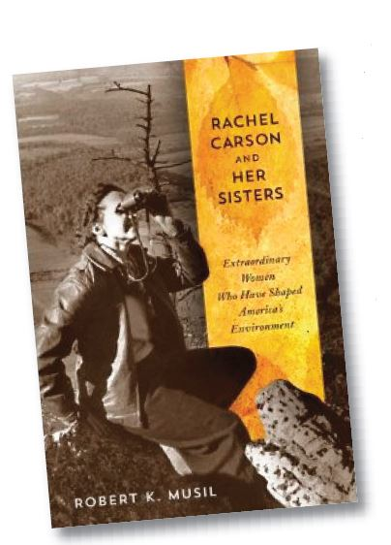 | Tuesday, April 21, 2015  4:00 – 6:00 pm  AOK Library, 7th Floor  Organic refreshments
Author: Dr.Robert K. Musil  President, the Rachel Carson Council,  Senior Fellow, Center for Congressional  and Presidential Studies,  American University, former CEO,  Physicians for Social Responsiblity |  | 