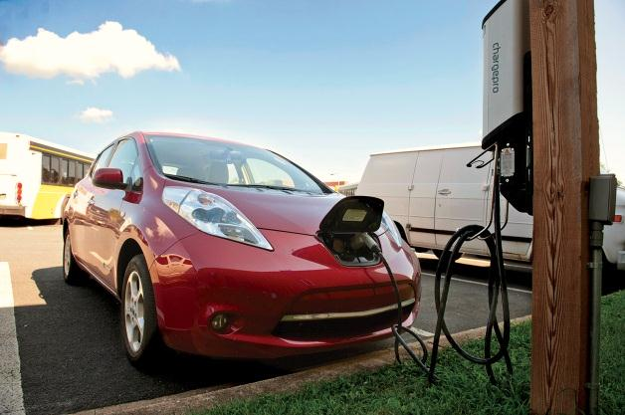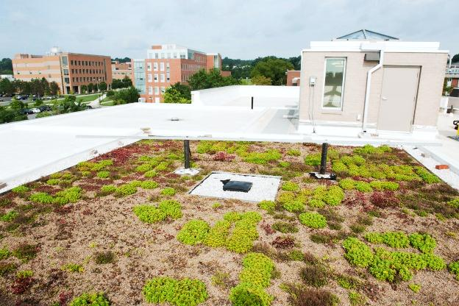

Patapsco Hall’s addition is a LEED-Gold building, topped with the campus’s first green roof.

**UMBC is committed to reducing carbon emissions 25% by 2025!**

**What We’re Doing**

Chilled Water Optimization

UMBC has upgraded the campus cooling systems to improve the efficiency. The project is conserving about 5, 700,000 kilowatt hours annually and has reduced greenhouse gas emissions by 3,100 metric tons of carbon dioxide, reducing the campus carbon footprint an additional 3.5% on top of the 13.3% reductions achieved since committing to carbon neutrality in 2007.

Next Phase of Conservation Upgrades:

* Upgrade campus building interior lighting efficiency
* Install LED lighting in parking garages
* Implement web-based and weather-optimized irrigation controls
* Introduce demand-controlled ventilation for lecture halls

All of these projects will save 7, 000, 000 kWh and 3,000,000 gallons of water. In addition, we will reduce GHG emissions by 3,800 MteCO2 and carbon footprint by 4.3% per year. These are expected to be completed by 2013.

**What You Can Do**

* Turn off the lights every time, leaving any space
* Turn off and unplug unused electronics
* Set electronics to sleep or hibernate
* Set thermostats to 70oF in winter, 76oF in summer.
* Keep windows shut and do not use space heaters.

Always be energy smart:

Together, we make an impact

UMBC is always staying ahead, by now offering convenient locations to recharge electronic vehicles.

**Tanvi Gadhia**

**Environmental Sustainability Coordinator, UMBC**

**Admin 930, 1000 Hilltop Circle**

**Baltimore, MD 21250**

**sustainability.umbc.edu**

**E: sustainability@umbc.edu**

Month Day Year

Vol. 1 Issue 1

Vol. 1 Issue 1

Month Day Year

Insert Headline Here

Month Day Year

Vol. 1 Issue 1