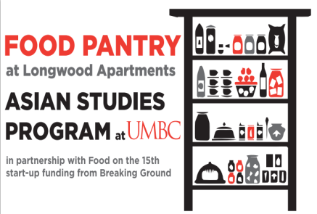

**NON-PERISHABLE**

**FOOD DONATIONS**

**NEEDED!**

**Suggested Items:**

* Canned tuna
* Spam
* Ramen and any type of Asian noodles
* Canned fruit (in its own juice)
* Soups

**Look for the red donation boxes in:**

* **Commons: by the reception desk**
* **Admin: by elevators on 1st floor**
* **RAC: by front desk**
* **UC: across from main entrance**
* **Library: right side as you walk in**
* **Shriver Center: inside their office**

The Food Pantry for low-income Asian senior citizens is **sponsored by the Asian Studies Program** and is staffed by ASIA 399 interns. This project (started through a UMBC BreakingGround grant) seeks to support low-income Asian senior citizens at the Longwood Apartments in Columbia, MD by collecting and delivering non-perishable food to them. The number of people served by our program has increased by 400% in one semester --from 20 to 90 residents, which means we need even more donations!

**Contact Julie Rosenthal at** [**julier@umbc.edu**](mailto:julier@umbc.edu)**, 410-455-2094 for info about internships and donations.**

**FOOD DRIVES ARE CONTINUOUS**

**Please donate as often as possible and please consider holding a food drive for us at your holiday party!**